**CLIENT-PREFERENCE FOR HOUSE AND BUILDING ARCHITECTURAL DESIGNS: A WEB APPLICATION FOR AEVG BUILDERS**

**_______________**

**A Capstone Project Presented to the**

**Faculty of the College of Information and Communications Technology**

**Bulacan State University**

**City of Malolos**

**_______________**

**In Partial Fulfillment** **of the Requirements for the Degree**

**Bachelor of Science in Information Technology**

**_______________**

by:

**BRITNEY DR. MACAHILIG**

**CARL JOHN G. BAUTISTA**

**HANNA CLARISSE J. SAGUN**

**HAROLD P. DE LEON**

**JUNER CHRISTIAN D. TARIPE**

**MARY GABRIELLE G. PANGAN**

**VON CEDRIC V. MARTIN**

(BSIT 3N)

**TABLE OF CONTENTS**

**TITLE PAGE Page**

**ENDORSEMENT FORM . . . . . . . . . . . . . . . . . . . . . . . . . . . . . . . . . . . . . . . . . . . ii**

**TABLE OF CONTENTS . . . . . . . . . . . . . . . . . . . . . . . . . . . . . . . . . . . . . . . . . . . . iii**

**LIST OF TABLES . . . . . . . . . . . . . . . . . . . . . . . . . . . . . . . . . . . . . . . . . . . . . . . . . .**

**LIST OF FIGURE . . . . . . . . . . . . . . . . . . . . . . . . . . . . . . . . . . . . . . . . . . . . . . . . . .**

**LIST OF APPENDICES . . . . . . . . . . . . . . . . . . . . . . . . . . . . . . . . . . . . . . . . . . . . .**

**CHAPTER**

1. **INTRODUCTION**

|  |  |
| --- | --- |
| Project Context . . . . . . . . . . . . . . . . . . . . . . . . . . . . . . . . . . . . . . . . . . | 1 |
| Purpose and Description . . . . . . . . . . . . . . . . . . . . . . . . . . . . . . . . . .  General and Specific Objectives. . . . . . . . . . . . . . . . . . . . . . . . . . . . . . | 2  3 |
| Scope and Limitations . . . . . . . . . . . . . . . . . . . . . . . . . . . . . . . . . . . . . | 4 |

|  |  |  |
| --- | --- | --- |
| **II. REVIEW OF RELATED LITERATURE AND STUDIES** |  |  |
| Relevant Theories . . . . . . . . . . . . . . . . . . . . . . . . . . . . . . . . . . . . . . . . | 6 |  |
| Related Literature . . . . . . . . . . . . . . . . . . . . . . . . . . . . . . . . . . . . . . . . | 8 |  |
| Related Studies . . . . . . . . . . . . . . . . . . . . . . . . . . . . . . . . . . . . . . . . . . | 10 |  |
| 1. **TECHNICAL BACKGROUND** |  |  |
| Software Development Methodology . . . . . . . . . . . . . . . . . . . . . . . . . | 12 |  |
| Requirements Analysis and Documentation . . . . . . . . . . . . . . . . . . . . . | 14 |  |
| Design of Systems. . . . . . . . . . . . . . . . . . . . . . . . . . . . . . . . . . . . . . | 17 |  |
| Description of the Prototype. . . . . . . . . . . . . . . . . . . . . . . . . . . . . . . . . | 41 |  |
| **BIBLIOGRAPHY. . . . . . . . . . . . . . . . . . . . . . . . . . . . . . . . . . . . . . . .**  **CURRICULUM VITAE. . . . . . . . . . . . . . . . . . . . . . . . . . . . . . . . . . . . . . .** | 50  52 |  |

|  |  |
| --- | --- |
| **CHAPTER I**  **INTRODUCTION**  This chapter serves as the introduction of the study and will provide background information about the project context, objectives of the study, the purpose of the study, and its scope and limitations.  **Project Context**                 Client-preference web applications have been introduced to various kinds of institutions due to the innovation and digitalization of different technologies, this includes Architectural and Building Institutions. Client-preference web application in the field of construction provide a lot of functions that can improve the transaction and gathering of materials to their clients such as user management and order list system. Client preference designs is one of the important ways of discussing what kind of design of house or building is what the client really wants to be build. And with the advancement of our technology, online transactions has become a trend not just in shopping but also in our day-to-day transactions.                 Client-preference web application has been an important part of every institution due to their positive outcome. It grants optimization and ease to the processes happening in different sectors and departments. Institutions like architectural and construction institutions often follow manual processes such as inventory mangement of the materials that covers a lot of time to carry out which leads to a slow workflow and adds a burden to the employees. One of the architectural and construction institutions that experienced this problem is AEVG builders who is still using manual estimation and transaction.                 Architect Yel Villalon Galang founded the AEVG builders in 2017. Architect Galang began his professional career in Singapore. After 2 years of working in Singapore Architect Galang decided to start his own design and construction company at San Pablo, Hagonoy Bulacan. The design and construction company has been operating at a high level of excellence for exactly 5 years, they provide the quality of design and construction and being progressive and competitive in the design and construction industry.                One of the serious problems at AEVG builders is   consumption of working time for the  client who knows who is AEVG builders. Admin and staff of AEVG builders are currently using manual inventory management. Most of the time, because of the usage of manual inventory, they consumed a large amount of time needed to for the materials.                The solution proposed by the researchers is development of Client-Preference for house and building architectural designs: A web application for AEVG Builders. This will help to resolve the current problems that AEVG Builders is experiencing such as manual inventory management. It will also make their work faster and can give the client satisfaction work.  **Purpose and Description**  This study is being carried out to develop a website application for AEVG Builders based on the preferences of their clients. Its goal is to highlight an architect's individual work inside the organization while also assisting with the client's material and financial estimates. The client can also look at the materials required in their plans and make an appointment with the firm's architect.  There are two (2) admin-level users and one end-user in this project. The Primary Owner or Head Admin, as well as the Owner or sub-Admin. The primary owner has full administrative control over the system. While the owner has access to all administrative rights over the system except those restricted to the primary owner, such as adding and deleting of roles accounts. The end-user on the other hand can fully browse the website application but the user must log in to estimate material costs and schedule an appointment with the company's architect. The following people will benefit from the study:  **Primary owner and owner.** They can simply track, save, and retrieve records of the goods and projects that clients require, as well as their appointments with architects. Control the profile of their employees. They may also show off their personal work by uploading it to the website, allowing them to provide outstanding service to their customers.  **End-users.** Customers could search for a certain blueprint, check material pricing, and calculate the cost of their plans. They could also make an appointment with a firm architect.  **Future researchers.** This study and its conclusions will serve as the foundation for future research on client-preference web application for building and architectures, particularly those that will use web application.  **General and Specific Objectives**  The main objective of this study is to design and develop a Client-Preference web application for house and building architectural designs intended for AEVG Builders.   Specifically, this study has the following objectives:   1. To analyze the existing business process of AEVG Builders and provide solutions to the identified problems. 2. To design and develop a web-based management system that integrates the following features:   2.1 Login system;  2.2 Home page;  2.3. About us page for contact details;  2.4. Services that AEVG Builders offers;  2.5. Portfolio projects;  2.6. Construction Materials;  2.7. User Management  2. To develop a  responsive web-based system that will integrate different features for the use of the employee as follows:  2.1. Project Uploads for Portfolio;  2.2. Request an Appointment;  2.3. User profile management;  3. To evaluate the developed web application using ISO/IEC 25010:2011 characterized as follows: : (1) Functional Suitability; (2) Performance Efficiency; (3) Compatibility; (4) Usability; and (5) Reliability; (6) Security; (7) Maintainability; and (8) Portability.  **Scope and Limitation of the Study**  The study aims to create a client-based architectural website system that will allow customers to view projects that this architectural firm is offering. This system can generate information about the project that was created previously, including the details of each project that was created. This study intends to create a website based on the AEVG Builders Company.                 This system will be covering a user and client-side, which are two different log-in systems. The user side, which are the potential customers, will be given an account which unlocks, a feature to send a direct appointment to the architectural firm. The client-side will take part on two user levels, the first one will be the employee, and the superior one is for the employer of the company.             The client will be able to look at the digital footprint of the user, which they will be given the data. The difference between the employee and the employer side of the website is that the employee has only the ability to edit and manage the website's data, the employee can also upload projects that the company has created. However, the employer has the ability to edit, add, and delete a user or an employer's account.    **CHAPTER II**  This chapter focuses on the different related literature and studies.  **Review of Related Theories**  **A Cultural Study of E-Commerce Trust: Hispanic Versus Anglo**  According to a cultural study of e-commerce trust conducted by Changchit, Garofolo and Gonzales (2009), ICT acts as a link between customers and businesses. It helps both parties' consumers and businesses. Web design is a customer's first impression of any facility and its quality. Furthermore, the quality' information system constantly examines customer satisfaction and the use of e-commerce to directly enhance the merchandises and services of companies with other businesses in the form of partnerships among suppliers, retailers, planners, and customers through several needed-System to develop not only fit and safe but also trustworthy in terms of safety.  **A Framework for Exploring the ICT Impact on the Architectural Design Process**  On a study conducted by Anita Moum (2006), processes can be sped up and conventional phases can be merged with the use of ICT. Traditionally, subsequent participants can have access to the 3D product model, for example, at a relatively early stage of the design process. Contractors, experts, and manufacturers all have information that can assist eliminate uncertainty early in the design process. The "wheel of dominance" (Gray and Hughes, 2001), which depicts which individuals control which planning phases of the design process, might shift. The overlap between early and later planning phases may lead to limitations that enhance the complexity of the solution and issue solving, making it more difficult to focus on the appropriate components at the appropriate moment. The utilization of information and communication technology, in this case a 3D product model, helps to a "land rising," in which numerous little islands "melt" into one large island. As a result, conventional divisions between jobs or stages of planning would blur and shift. The individual components of the planning process melt together and form a conglomerate. Understanding these many shifts is crucial. ICT has an influence on work procedures, jobs, and responsibilities.  **ICT and the Architectural Design Process – Introduction of an ICT Impact Matrix**  Another study conducted by Anita Moum (2008) concluded, the development of the ICT impact matrix is one strategy to addressing the vast variety of ICT influences on the complicated area of architectural design process. The methods of architectural design and decision-making may be related to the nature of the design challenge itself: multidimensional and interactive, depending on the interconnectivity of several aspects. A critical question from the perspective of an architect is how ICT-related advantages and problems affect his role, influence, and contribution to the architectural design process and decision-making.  **Architectures in Context: On the Evolution of Business, Application Software, and ICT Platform Architectures**  According to the study of Aerts, Goossenaerts, Hammer and Wortmann (2003), any of today's advances are enabled by ICT-architectures. Because it cannot give flexibility, application-based integration loses its appeal. The task-based UI paradigm emerges. Instance mark-up is used in the definition of data structures. Based on standards such as XML, every data will most likely become self-descriptive and contain its own meta-data. Rather than implementing as executable code, the processing flow and logic will be contained in models. Self-descriptive models will be used. Based on a particular scope, application sessions will be produced.  The current era appears to be characterized by extreme innovation. Different business conceptions and structures are required by the new ways of communication and cooperation. To allow inter-enterprise collaboration, dependability criteria like security and trust must be handled on a global scale.  **Review Related and Literature**  **Intelligent designer: A computational approach to automating design of windows in buildings.**  According to Karan & Asadi (2019), intelligent designer: a computational approach to automating design of windows in buildings stated that interaction of building configuration is a method for meeting client assumptions for a structure, trailed by a bunch of complete norms and codes connecting with the plan, development, and support of structures. The quickly rising volume of information alongside expanding client assumptions roused numerous scientists to foster new mechanized strategies to computerize building configuration process. These strategies can be stalled into two general classifications: robotized PC supported plan instruments (e.g., improvement of building data demonstrating or BIM) and estimating or displaying client assumptions (e.g., utilization of looks to track down mental assumptions for the client). Propels in computerized reasoning (AI) and AI have made conceivable new ways to deal with the computerization of plan. This addresses a shift from an emphasis on client-fashioner or creator innovation connections to a more shrewd and autonomous client-innovation correspondence. In this paper, an original AI framework called wise originator is proposed to comprehend (or learn) the client's need and assumptions and create substantial plans. The plan climate (i.e., the cooperation between the client and the plan) is formed as a Markov choice cycle (MDP) and a numerical system is accommodated going with plan choices in circumstances where new plans are part of the way irregular (as they are impacted by the client's criticism) and somewhat heavily influenced by the PC (as they are affected by the guidelines, norms, and rules). The methodology is shown utilizing a window configuration explore.  **Building Information Modelling in UK Construction Projects: A State of the Art Review**  According to Georgiadou (2016), building information modelling in UK construction projects: a state of the art reviews stated that paper plans to introduce a cutting edge survey of the degree and functional ramifications of the Building Information Modeling (BIM) stage in the UK development practice. Hypothetical advancements recommend that BIM is a coordination of both item and interaction development, in addition to a unique arrangement of programming instruments. BIM gives compelling joint effort, visual portrayal and information the board, which empower the smooth progression of data all through the venture's lifecycle. The most often revealed benefits are connected with Capital Cost (capex) and Operational expenses (opex) and time reserve funds. Key difficulties, nonetheless, center on the interoperability of programming, capital establishment costs, in-house insight, client inclination and social issues inside plan groups and inside the association. The paper finishes up with a basic analysis on the changing jobs and a cycle expected to execute BIM in UK development projects, and recommends regions for additional exploration.  **Building performance simulation in the early design stage: An introduction to integrated dynamic models**  According to Negendahl (2015), building performance simulation in the early design stage: an introduction to integrated dynamic models stated that planning with building execution reenactment input in the early plan stage has existed since the beginning of computational displaying. Be that as it may, as a result of a divided structure industry building execution recreations (BPSs) in the early plan stage are firmly connected with who is making and working the BPS models. This paper basically audits the various ways fashioners and examiners use BPS in the early plan stage. One of the key discoveries is that most devices and techniques utilized in the early plan stages are deficient to give substantial criticism while in a similar time being sufficiently adaptable to oblige a fast changing plan process. The primary concern focuses to how mathematical models and logical models are consolidated and how this influences how the structures are planned and perform. This paper infers that coordinated powerful models might join a plan apparatus, a visual programming language and a BPS to offer better help for the architect during the beginning phases of configuration instead of options, for example, the ongoing execution of IFC or GB XML or the unaccompanied utilization of reenactment bundles.  **Related Studies**  **A Choice Model of Mass Customized Modular Housing by Internet Aided Design**  The Internet, according to Joseph Chuen-huei Huang, has improved the chances to apply the concept of mass customization to customer engagement by personalizing material to individual needs. Customers can choose the choices they want within certain design limitations by participating in the design process from the start. This notion has already been adopted in the computer, apparel, and vehicle industries, but it has yet to be fully incorporated into architecture, particularly in the housing industry, which is more closely tied to personal lifestyle. The business lacks a method for customizing homes to reflect the residents' individual values and wants. The article uses examples from the existing prototype to describe the relationship between the client's needs and the proposed system's possible design options.  A suggested web-based design system will give information filtering questions to aid clients in picking acceptable design components by incorporating the characteristics of modularity in prefabricated dwelling design. A methodology has been established that may generate design possibilities based on the demands of the customer and available modular components from selected product providers, allowing the final design to be simulated before processing orders for assembly and manufacture.  **Low Cost Web-Application For Management Of 3d Digital Building And Complex Based On Bim And Gis**  S.W. Trisyanti, et al (2019) conducted study using an open-source web-application for asset and facilities management. This web application can show two-dimensional (2D) GIS and BIM data, but not three-dimensional (3D) GIS data. Using 3D City Database (3D CityDB), which is integrated with the web-application, the findings of surveying and mapping, as well as existing architectural drawings, may be used to create 3D GIS data. Their research aims to save building and city data, show it in a 3D model, and use it for spatial analysis in customized open-source online apps.              Because numerous technologies have emerged to handle data and information from a building or a city, they employ a Geographical Information System (GIS), which is a sort of information system designed to operate with data that refers to spatial or geographic coordinates. It's a database system with unique capabilities for spatial reference data, as well as a set of procedures to manipulate it. They also employ Building Information Modeling (BIM), a 3D modeling system that uses intelligent databases to store data on decision-making design, accurate construction document generation, performance factor prediction, cost estimation and scenario design, and construction planning.  **Developing a Cost-Effective Web-Based Communication and Information Management System for Construction Projects**  Construction projects confront various issues, according to MU Nanayakkara, et al (2021), due to a lack of well-organized communication and information management inside construction sites, particularly in their home nation of Sri Lanka. The site's traditional communication and information management system is nearly entirely based on old practices, causing the project to be delayed, mislead, and inefficient. That's why they undertook this research to create a low-cost web-based application for communicating, making decisions, and managing information on a building site that matched the conditions in Sri Lanka.  A web-based application (prototype) was created based on the collected expert opinions and their experience working on building sites in Sri Lanka. To obtain the relevant data, semi-structured interviews were employed, and content analysis was used to analyze it. After considering all of the above, a web-based prototype for managing communication and information on the construction site was created. The system provides features such as minimizing workplace contradictions by providing a virtual platform to connect with relevant parties, managing information by providing a virtual document storage in relevant areas, notifying tasks, and so on. |  |

**CHAPTER III**

**TECHNICAL BACKGROUND**

This chapter will discuss the different methodologies that the researchers will incorporate into the development of the system. This chapter provides information on the different phases of development of the system, its requirements, and description of the developed system and its functions.

**Software Development Methodology**

Many approaches are used in the creation of software products and other systems. The success of a project is determined by its software development methodology. It's impossible to accomplish product stability, safety, and the long-term viability of functional aspects without a carefully chosen approach. A software development methodology is a system for determining job execution order, assessment methodologies, and control. Software development models are chosen depending on the project's direction, budget, ultimate product timeline, and occasionally even the project manager's and team members' tastes. The stages of the software development life cycle differ by model. One of these models is the Agile model, which will serve as the system's software development process.

The basic principle behind Agile software development is to create a product in cycles. Agile emphasizes the importance of communication. Team members are constantly seeking user input and making software modifications. This method enables for the reduction of risks like problems, budget overruns, and requirement modifications as well as the addition of additional features as needed. Because the project's creators and customers are heavily involved, the researcher employs this methodology. Due to extensive testing, the software has few flaws and dangers. As the primary indicator of progress, the working product takes precedence.

The phases of the Agile model are as follows:

*Requirement Gathering.* You must define the criteria at this phase. Explain the commercial potential and the time and effort required to complete the project. You can assess technical and economic feasibility using this information.

With the help of the AEVG Builders client, the researcher planned and outlined the amount of time required to complete the project, as well as all pertinent facts on whether the project can be completed on time and within the researchers' capabilities. They also consider all the necessary website functionality for their client, as well as the project's limitations and scope.

*Design the requirements.* In this phase, the researcher must work with stakeholders to define requirements once the project was defined. To demonstrate how the new features function and how they will fit into your existing system, use a user flow diagram or a high-level UML diagram.

To depict the system's flow, the researchers use a variety of diagrams. Consider the flowchart. They also supply a prototype that illustrates the design and features of the system, in addition to a diagram that maps out the present or future website's structure and complexity.

*Construction/Iteration.* Work begins in this phase after the team has defined the requirements. Designers and developers begin work on the project, with the goal of delivering a functional product. The product will go through several rounds of development; thus, it will have basic, rudimentary functionality.

The researcher will begin working based on the client's and user's preferences, using all of the information obtained during the planning and design process, such as the flowchart, prototype, and other diagrams developed.

*Testing.* This phase examines the product's performance and looks for bugs. The system's software quality will be determined using ISO/IEC 25010:2011. The researchers will thoroughly test the system throughout this phase. In addition, if the user or the tester encounters any flaws or errors in the system, the researcher will create a survey.

*Deployment.* The team creates a product for the user's workplace in this phase and the final process. During this phase, the system will be put into production mode. The deployment of the system takes place here. Creating documentation and giving all essential tools to assist the customer and other users in understanding and effectively using the system.

**Requirements Analysis and Documentation**

Several aspects of the Client-preference web application should be discussed in order for the system to function properly. This contains the project's software and hardware requirements.

**Table 1**

**Software Requirements for the Web Systems**

|  |  |
| --- | --- |
| **Software** |  |
| Visual Studio Code | It is used for coding the website’s features and functionalities. |
| XAMPP | It is used to set up a local web server to run the website while it's being developed. |
| Webhost000 | It is used to upload files that enable the system to be tested and run. |
| Browser | It is used to run and access the website that is being developed. |
| Adobe Photoshop/Illustrator | It is a software application used to create the logo for the website. |

**Table 2**

**Hardware Requirements for Web Systems**

|  |  |
| --- | --- |
| **Hardware** |  |
| Processor | 3.3 gigahertz (GHz) or faster 64-bit dual core processor with SSE2 instruction set |
| Operating System | Windows 10 (64-bit) versions V1809, V1903, V1909, and V2004 |
| RAM | 4-GB RAM or more |
| Display | Super VGA with a resolution of  1024 x 768 |
| Internet Connection | It is required for software activation, also for uploading and testing. |

**Table 3**

**User Requirements for Web Systems (Software)**

|  |  |
| --- | --- |
| **Software** |  |
| Operating System | Anything that can use Browser to access the  website |
| Browser | It is used to run and access the website. |

**Table 4**

**User Requirements for Web Systems (Hardware)**

|  |  |
| --- | --- |
| **Hardware** |  |
| Laptop/Personal Computer | Device to be used in accessing the website. |
| Processor | 3.3 gigahertz (GHz) or faster 64-bit dual core processor with SSE2 instruction set |
| Internet Connection | To access the website. |
| RAM | 4-GB RAM or more |

**Design of Software, Systems, Product, and/or Processes**

Figures 2- 21 presents the diagrams used within the study. These diagrams were developed during the design phase of the software development methodology. The diagrams included and used in this study are entity-relationship diagram, context diagram, data flow diagram, USE Case, flowcharts, and visual table of contents.

**Use Case Diagram**

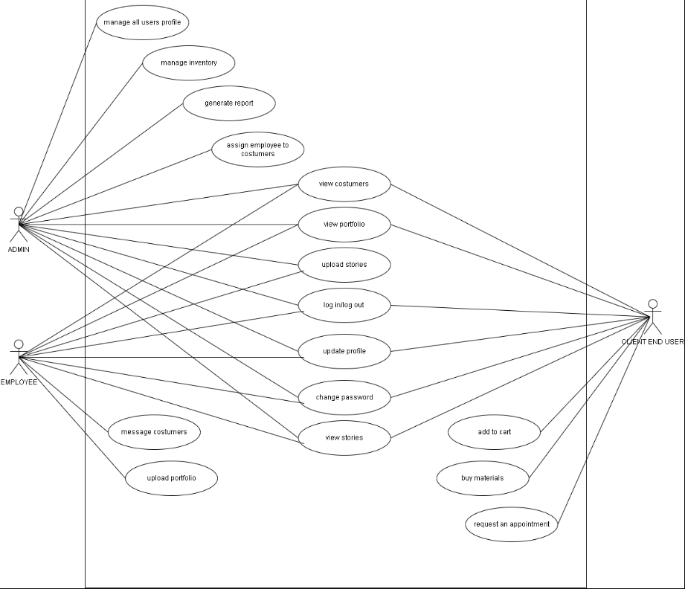

**Figure 2. Use Case Diagram**

This diagram depicts the various roles of three actors: administrator, employee, and client. an Admin who could control all of the users' profiles, inventories, and much of the system's functionality an employee who can manage materials, manage, message customers, and perform other responsibilities. Lastly, a client who is capable of purchasing materials, seeing portfolios, and contacting the architect to schedule an appointment.

**Context Diagram**

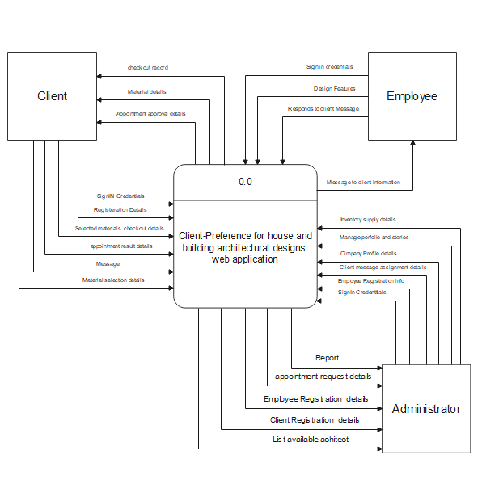

**Figure 3. Context Diagram**

This diagrams show the input and output process between three entities: Admin, Client, and Employee, as well as how they will interact with the system or website, AEVG BUILDERS.

**Data Flow Diagram**

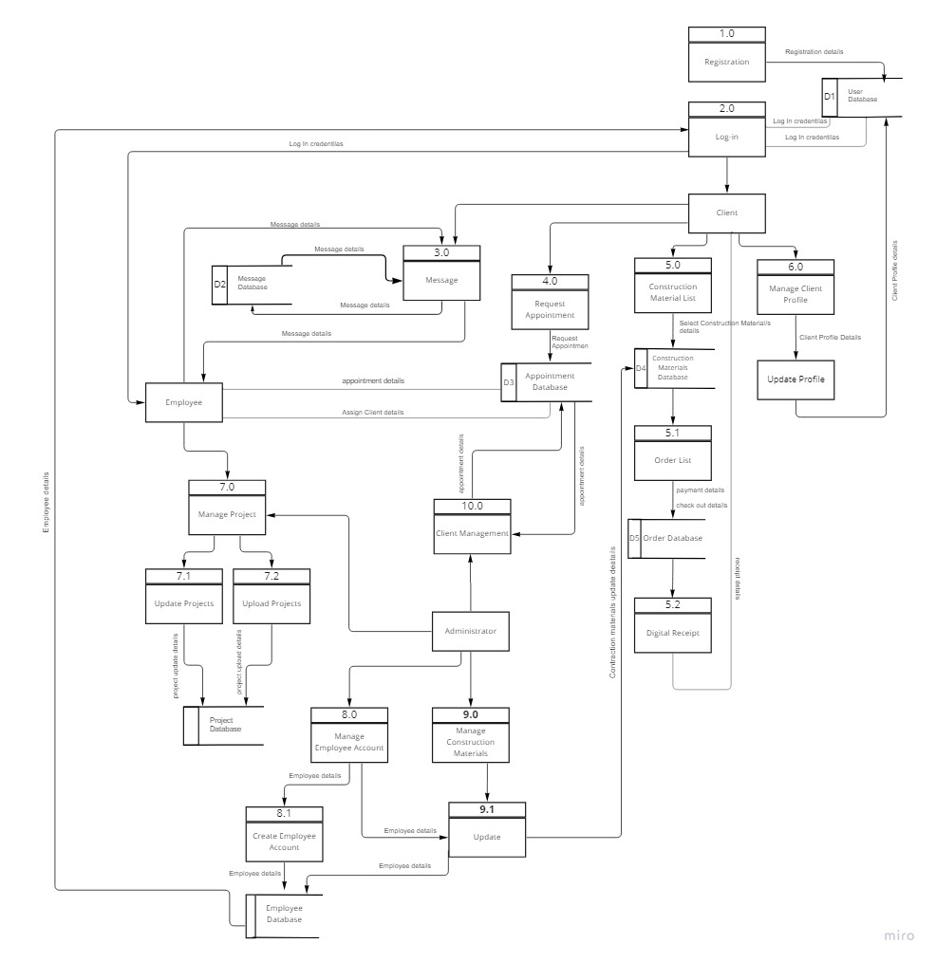

**Figure 4. Data Flow Diagram**

In the 12 processes above, the Data Flow Diagram (DFD) illustrates the data flow between three entities: Admin, Customer and Employee.

**Flowchart**

**Home Page**

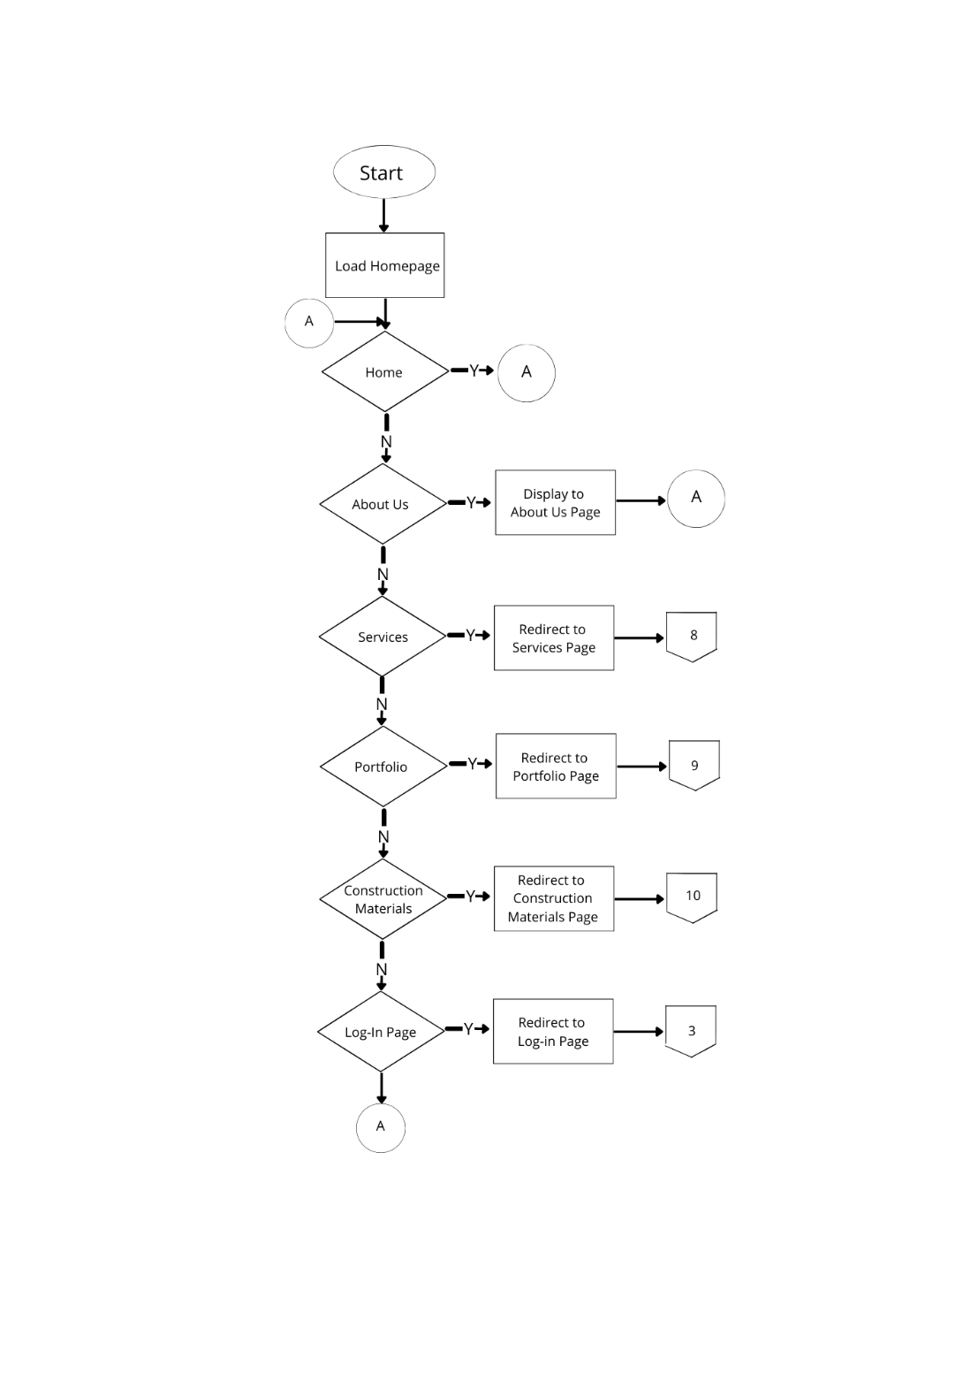

**Figure 4. Home Page**

This figure illustrates the load homepages indicates home, about us, services, portfolio, construction materials and log-in page.

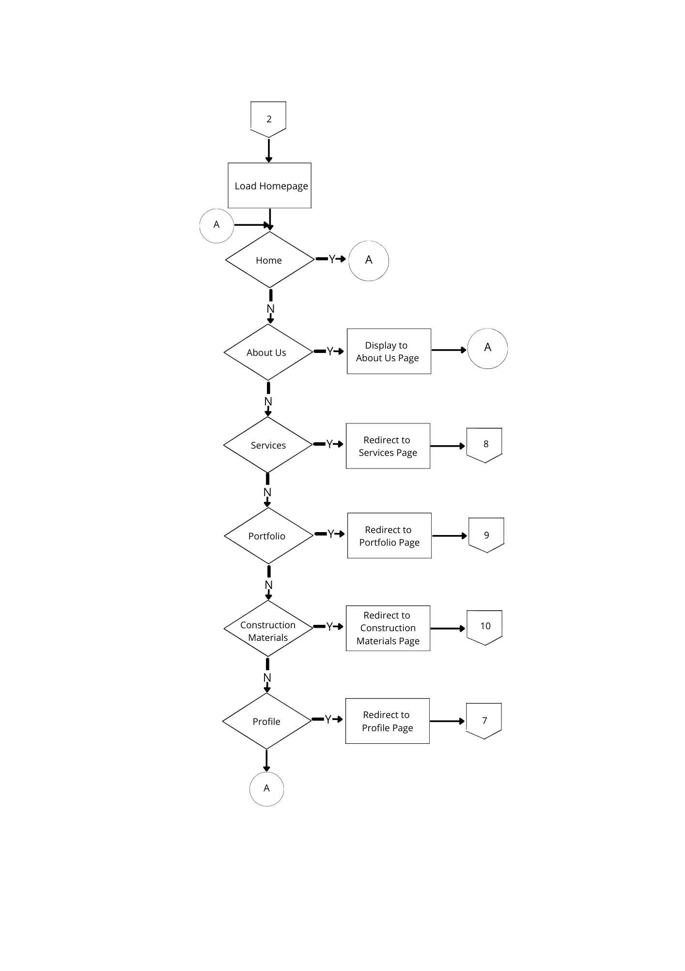

**Log-In**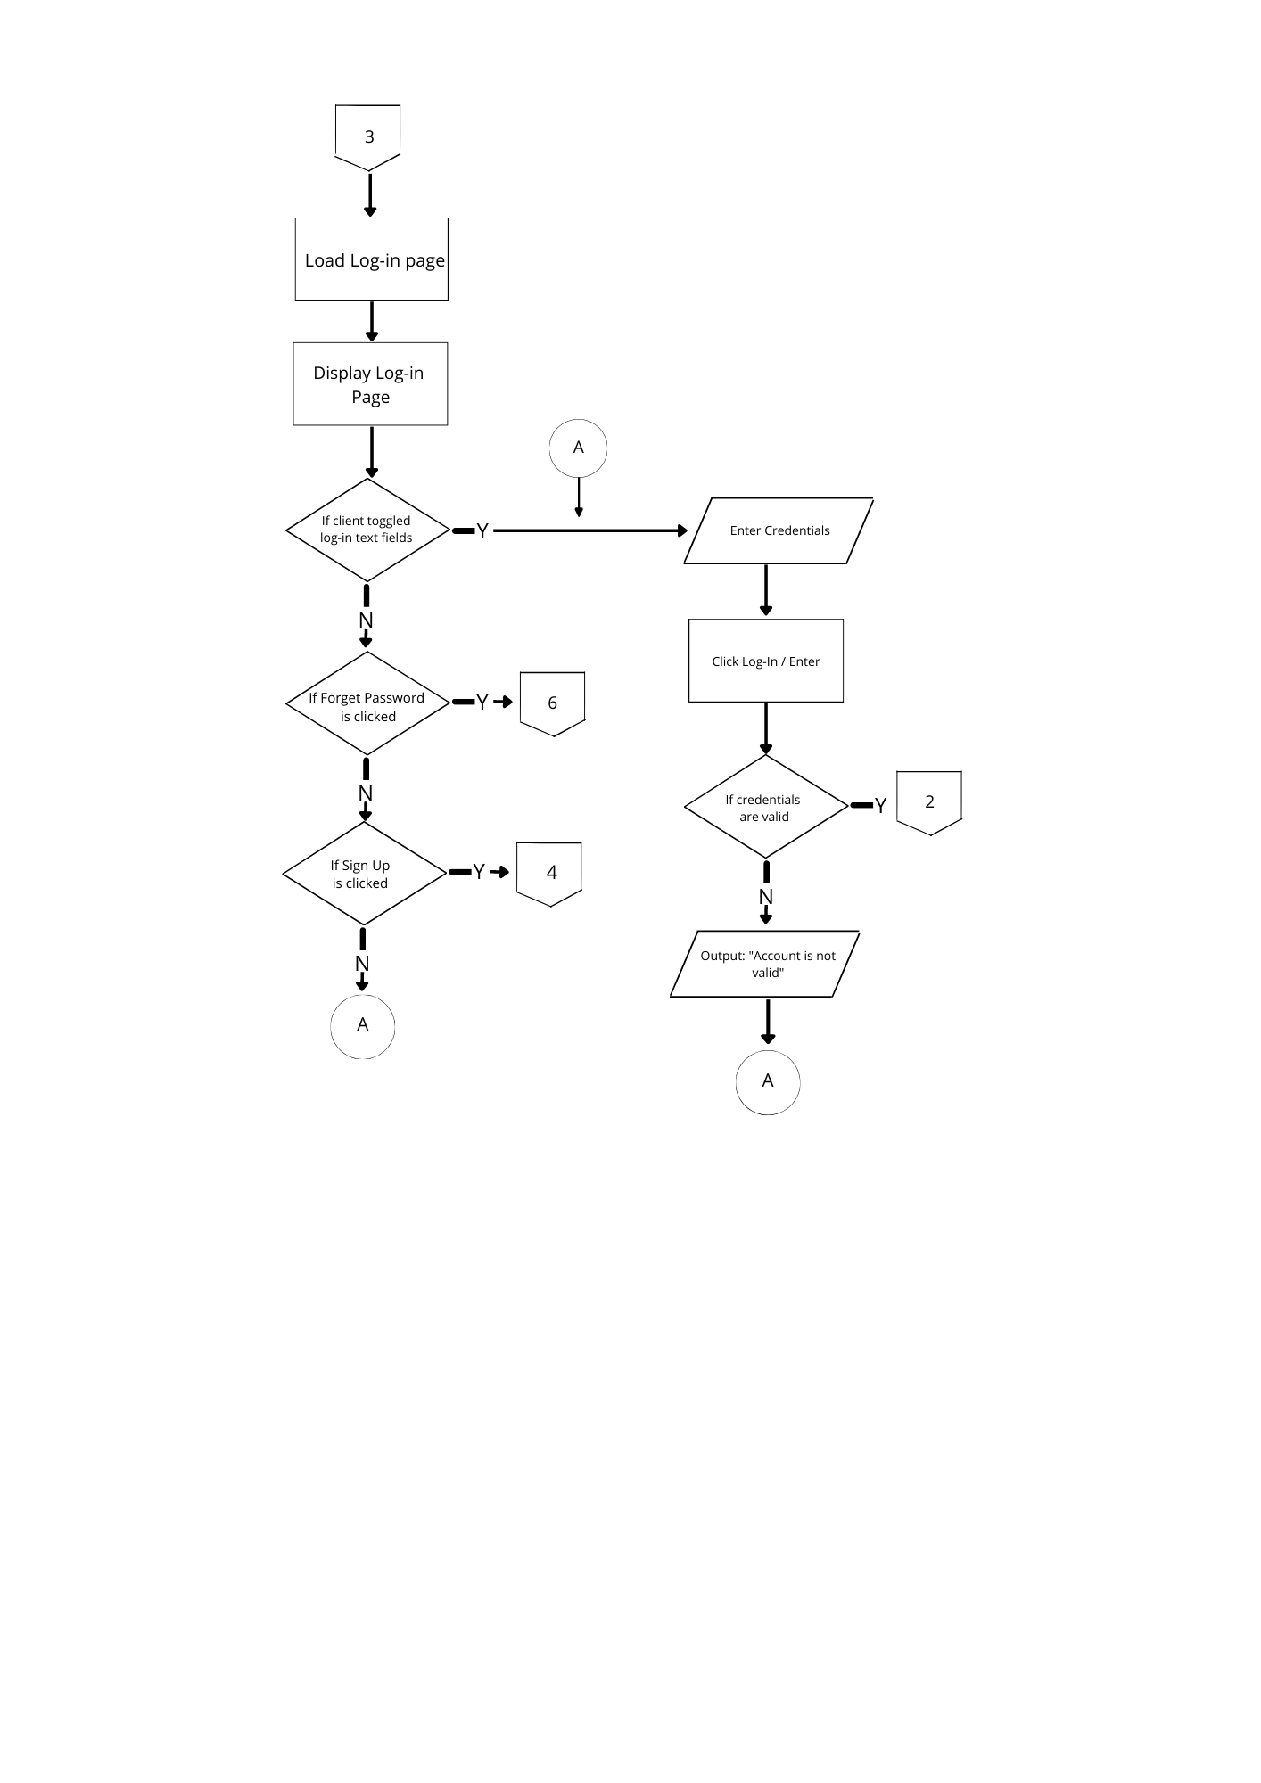

**Figure 5. Login Flowchart**

This figure illustrates the Login Flowchart the flow for the system's login feature before inputting their credentials, users will be able to select which sort of account they are attempting to login to, and the system will verify whether the account exists or not.

**Sign Up / Register**

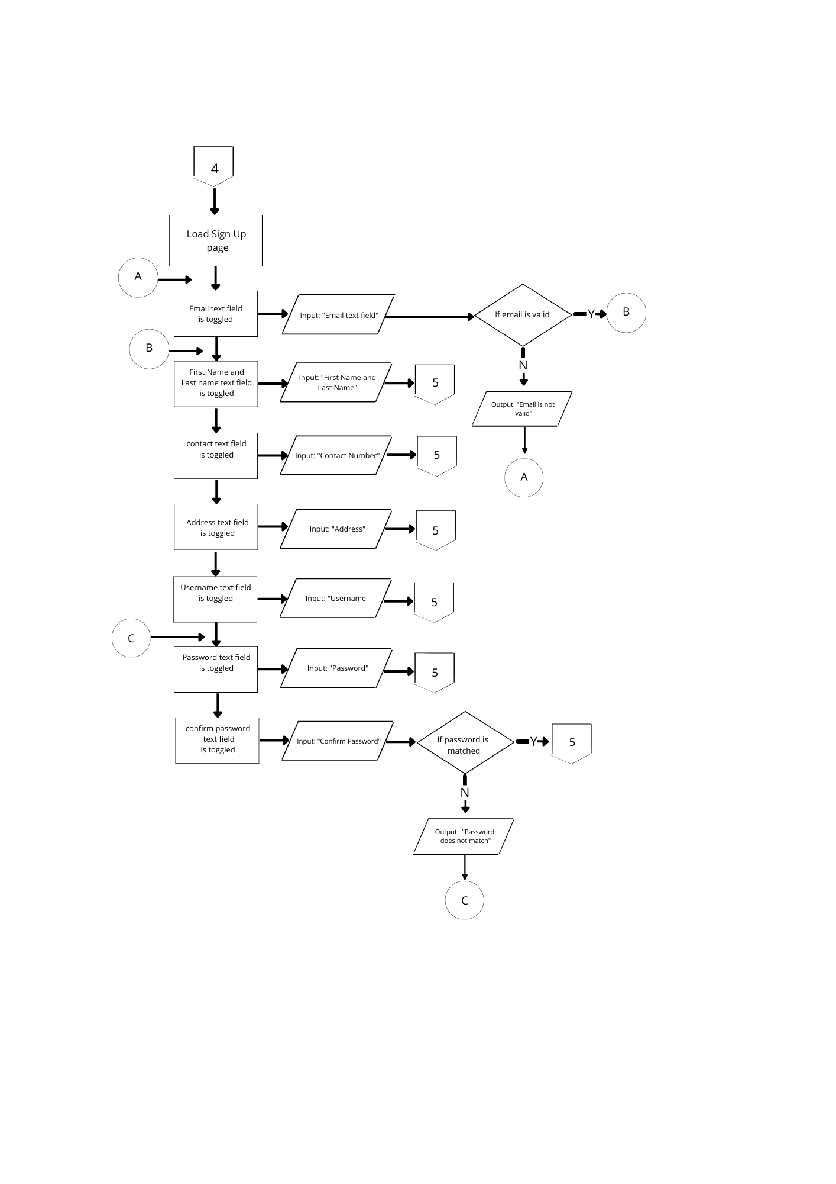

**Figure 5. Sign Up Flowchart**

This figure illustrate load sign up page to authenticate to an account that you have previously made. The term "sign up" simply refers to the process of enrolling for an account.

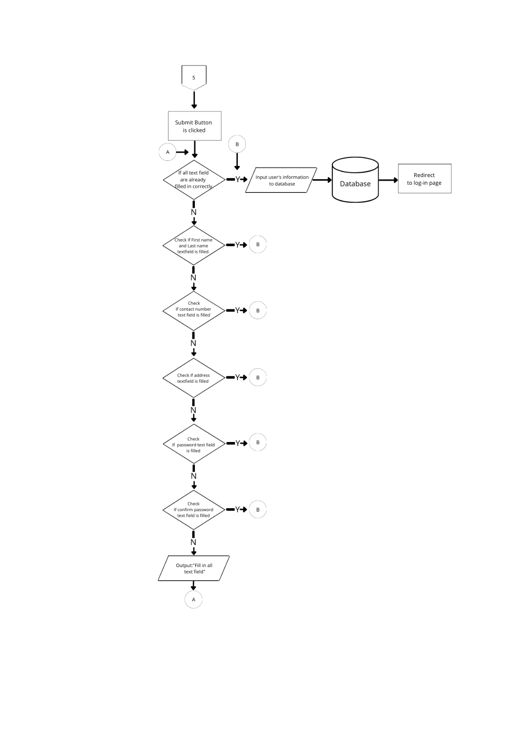

**Forgot Password**

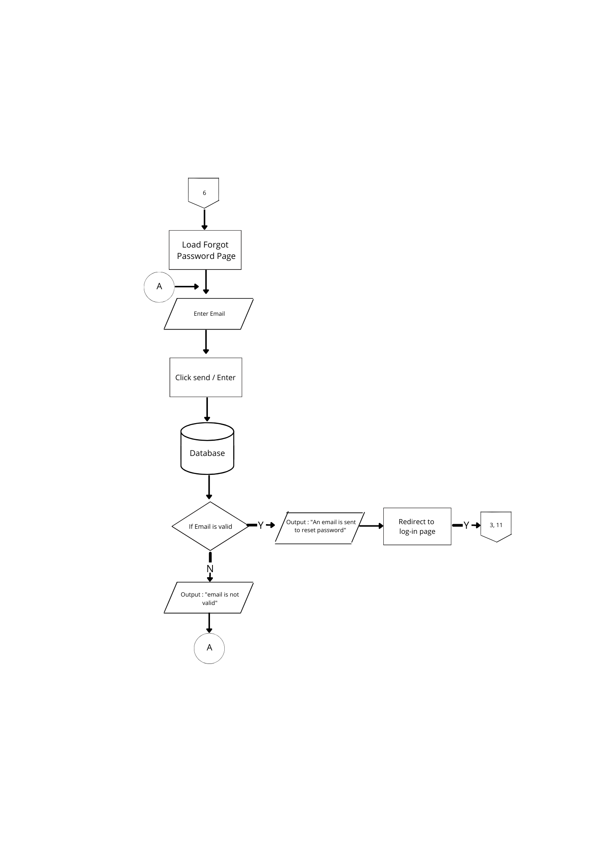

**Figure 6. Forgot Password Flowchart**

The method for the web system's lost password function is depicted in the diagram. If a user forgets their password, they will be asked to enter their email address to validate whether the account exists, and if it does, an email will be sent to the address with instructions on how to restore the account with the forgotten password.

**End User Profile**

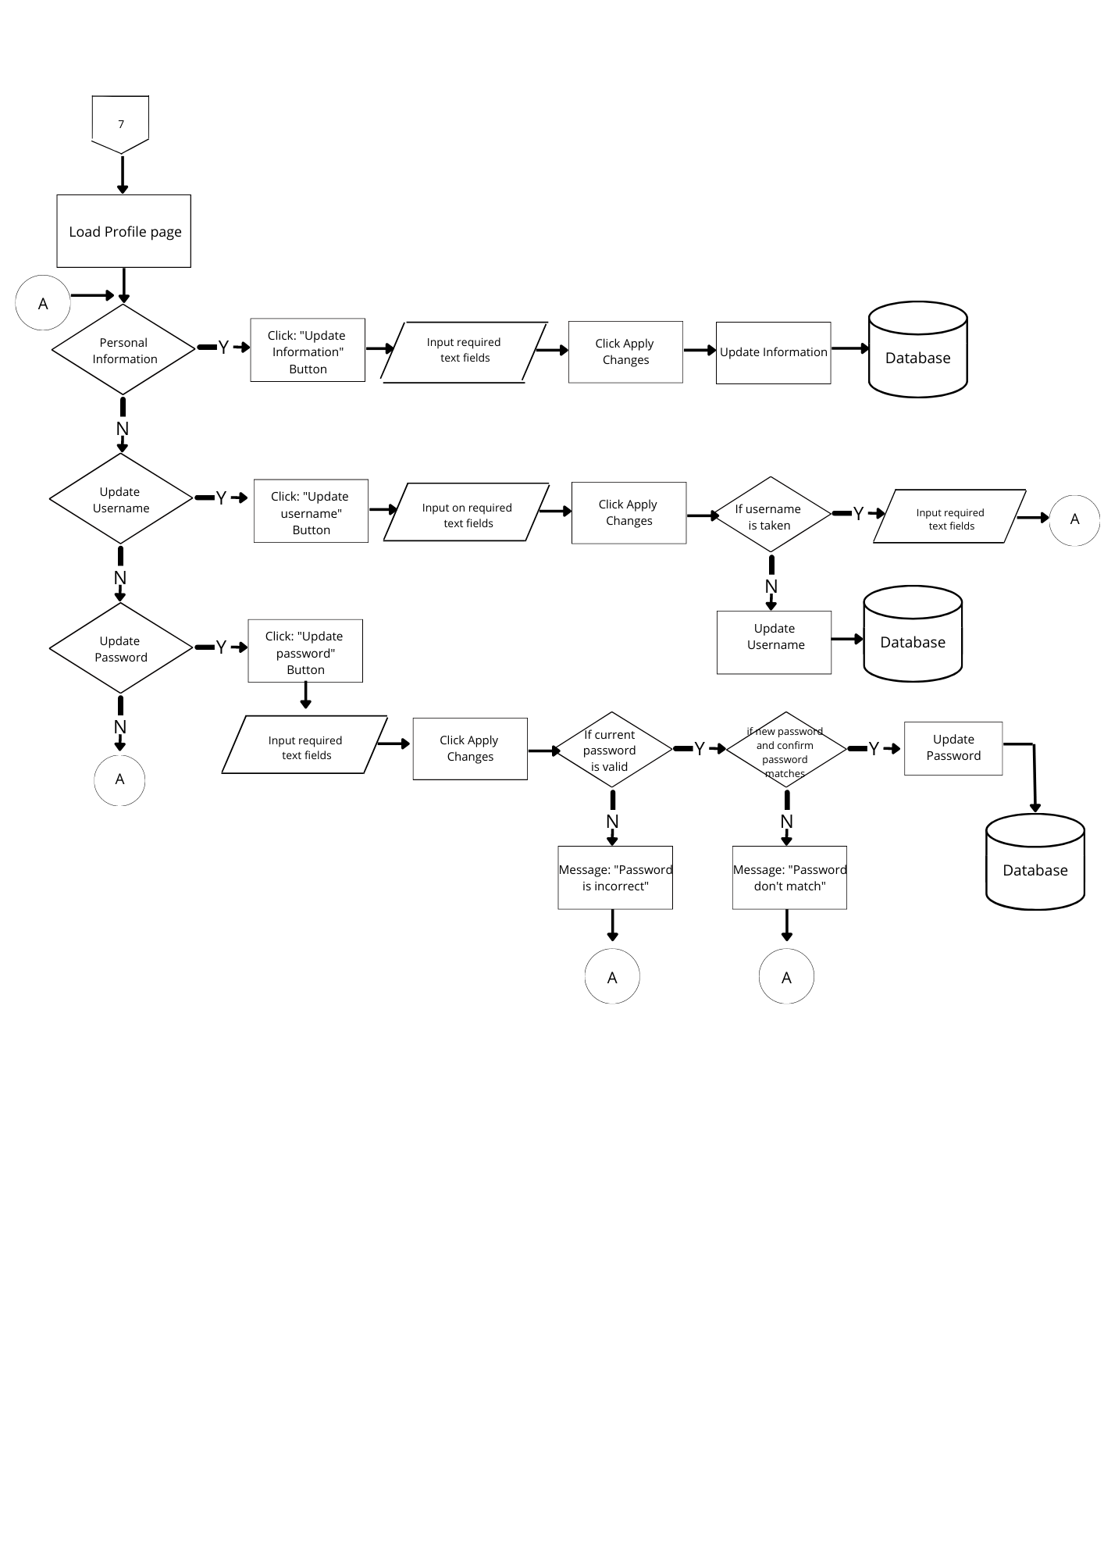

**Figure 7. End-User Profile Flowchart**

This figure illustrate the load profile page shows a graphic depiction of the load profile as well as data summary information. On this page, you can change the load's details.

**End-User Services Page**

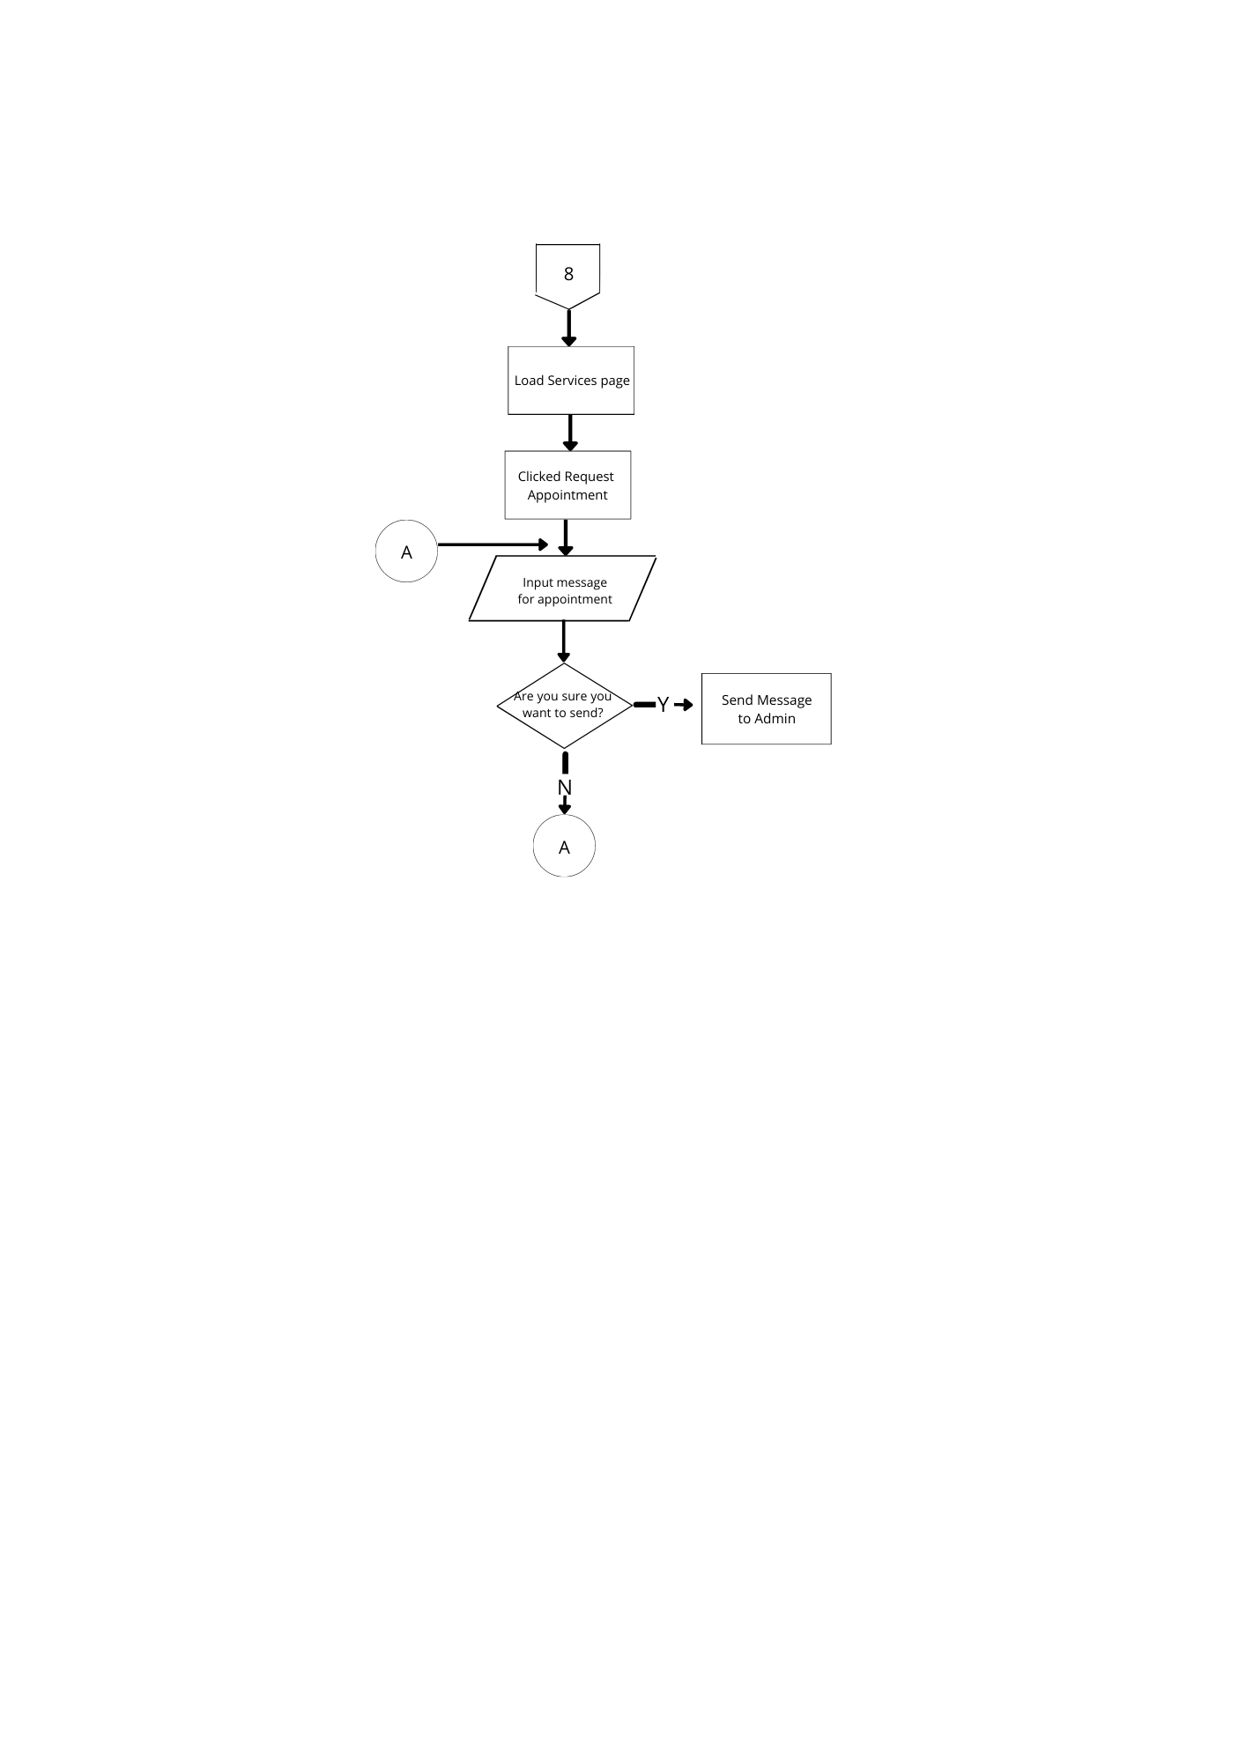

**Figure 8. End-User Services Flowchart**

This figure illustrate load services page included the request appointment to send a message to admin.

**End-User Portfolio Page**

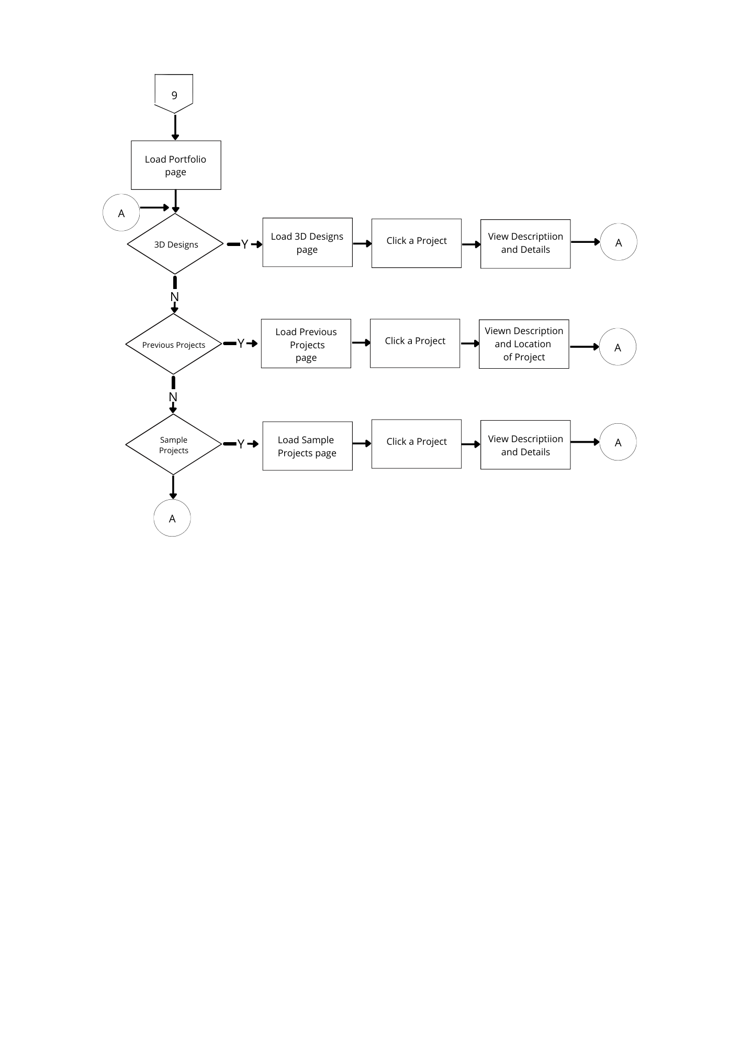

**Figure 9. End-User Portfolio Flowchart**

This figure illustrate should be used to showcase the best work to show to potential employers, clients, or interested people including 3D Designs, previous design and sample projects.

**End-User Materials Page**

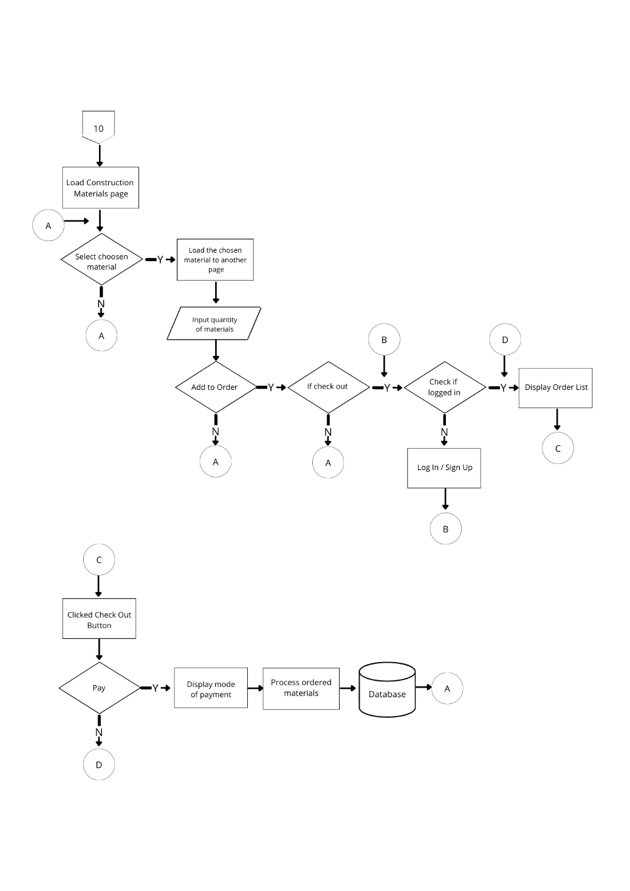

**Figure 10. End-User Materials Page**

This figure illustrate everything that is created or created as part of a project, or in connection with a project run or project, including materials, payment, orders, and process.

**Admin Navigation**

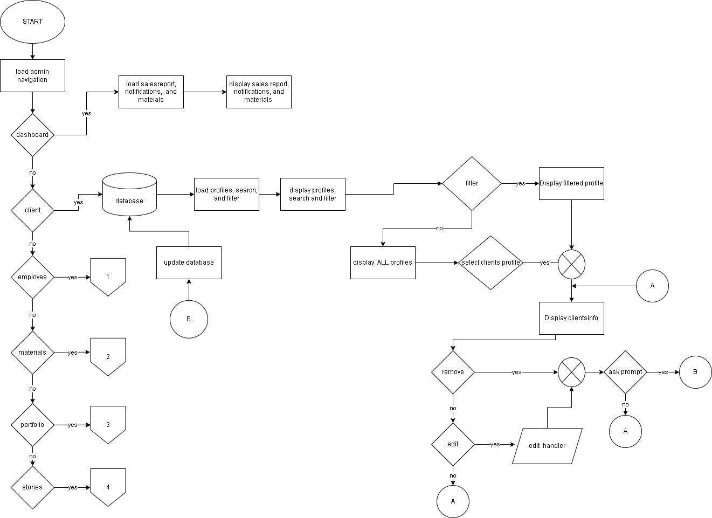

**Figure 11. Admin navigation**

The illustration above shows the flow of the Admin Navigation in our system. It shows the moves that the user can do such as manage dashboards, manage employees, view material, portfolio and stories. This also allows the admin to check client’s profiles.

**Employee**

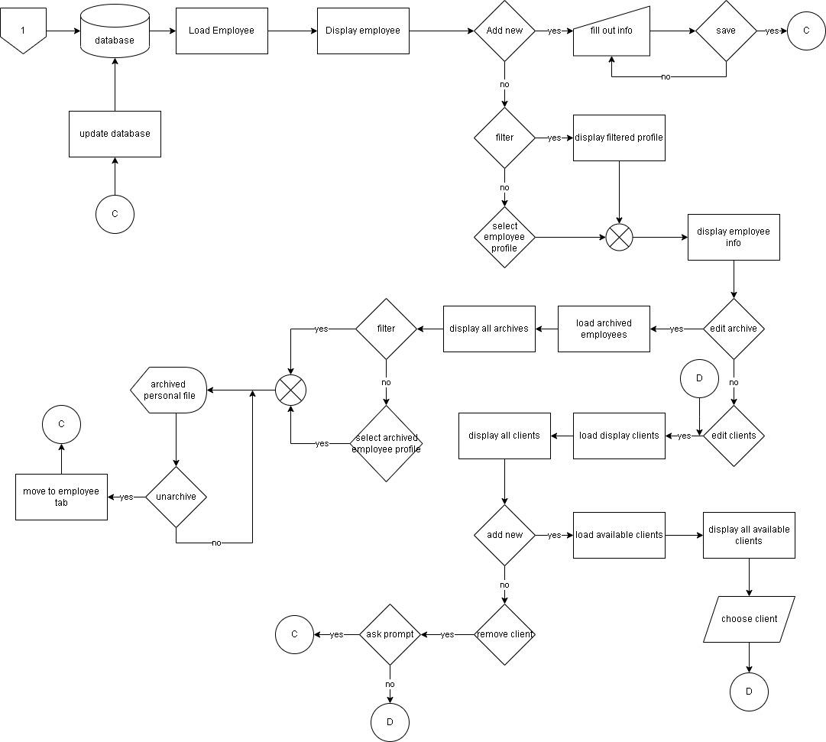

**Figure 12. Employees Flowchart**

The illustration below shows the flow of the employee part of our system. It shows that the admin is able to add employee and check the current employee's profile, information and their holding clients.

**Materials**

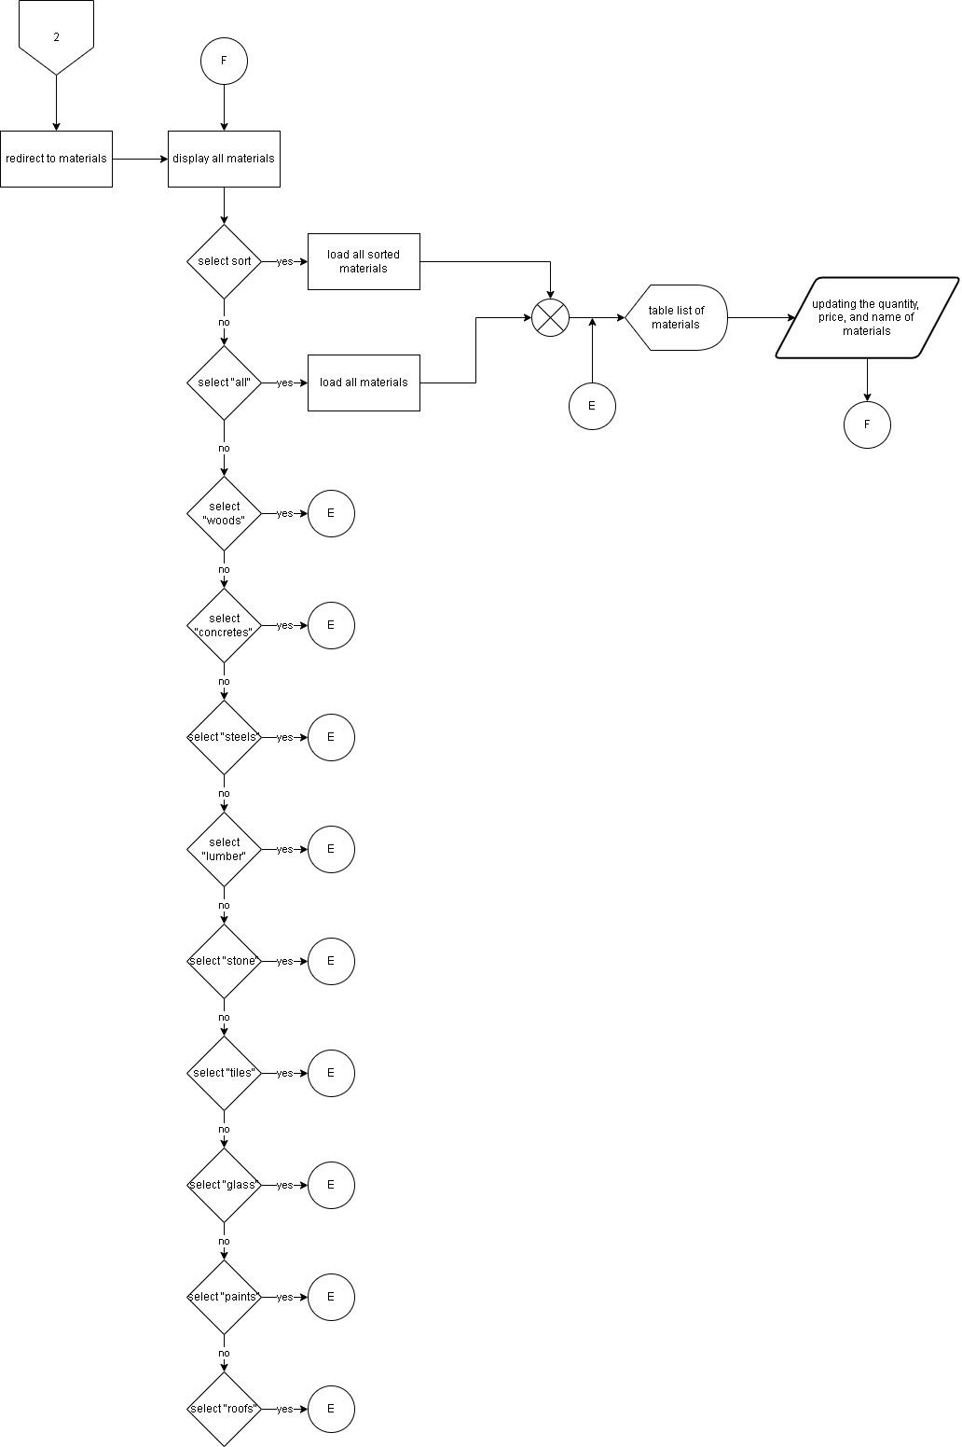

**Figure 13. Materials Flowchart**

The illustration above shows the flow of the material section of our system. This can allow admin to view the list of materials and be able to update the quantity, price and names of the materials.

**Portfolio and Stories**

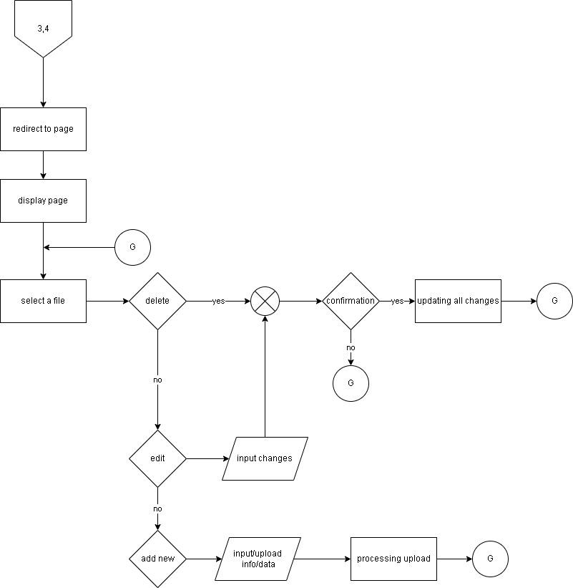

**Figure 14. Stories and Portfolio Flowchart**

B The illustration above shows the flow of the portfolio and stories section of our system. The admin is able to upload, edit, delete and update stories and portfolios.

**Employee LogIn**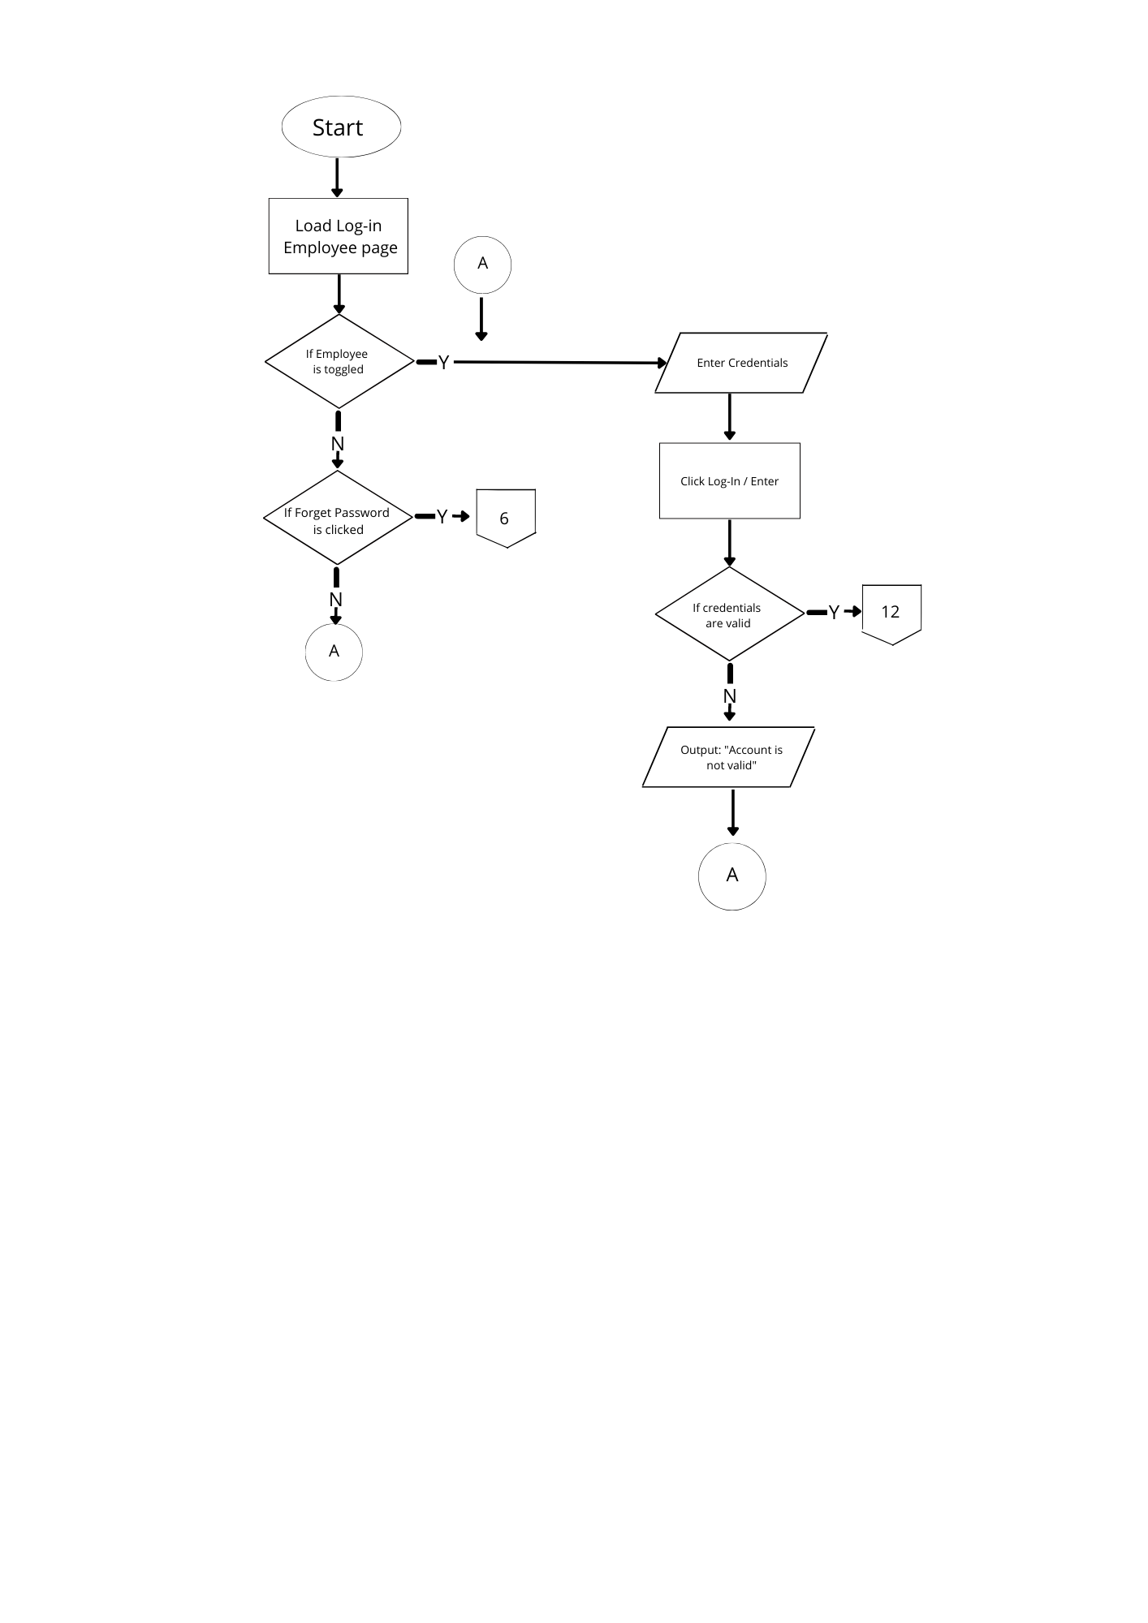

**Figure 15. Employee Log-In Flowchart**

This figure illustrate a list of all of the people the supplier uses to provide the services.

**Employee Home Page**

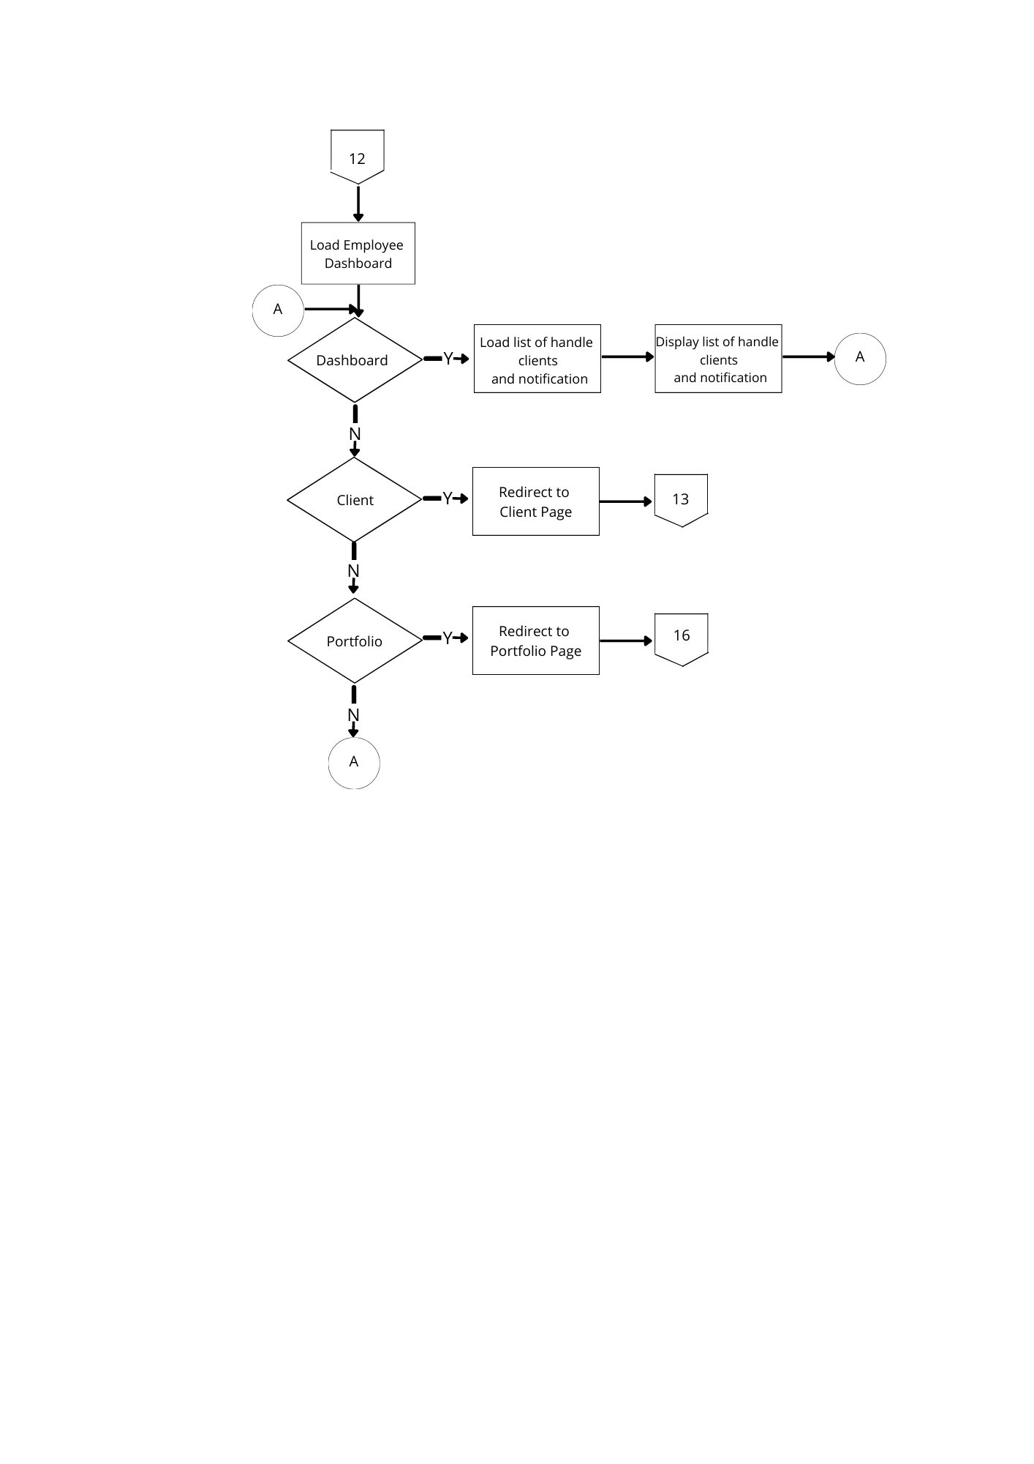

**Figure 16. Employee Home Page Flowchart**

This figure illustrate the employee homepage indicates dashboard that can handle clients and notifications.

**Employee Client Page**

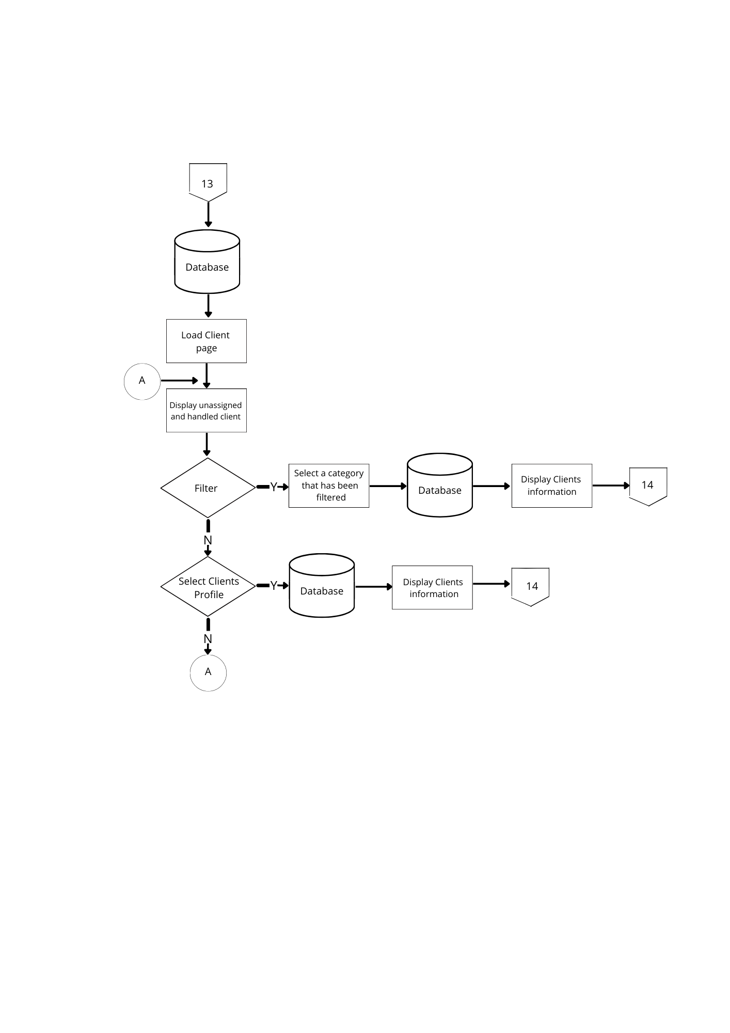

**Figure 17. Employee Client Page Flowchart**

This figure illustrate the employee client page indicates filter and select clients profile to display and select category.

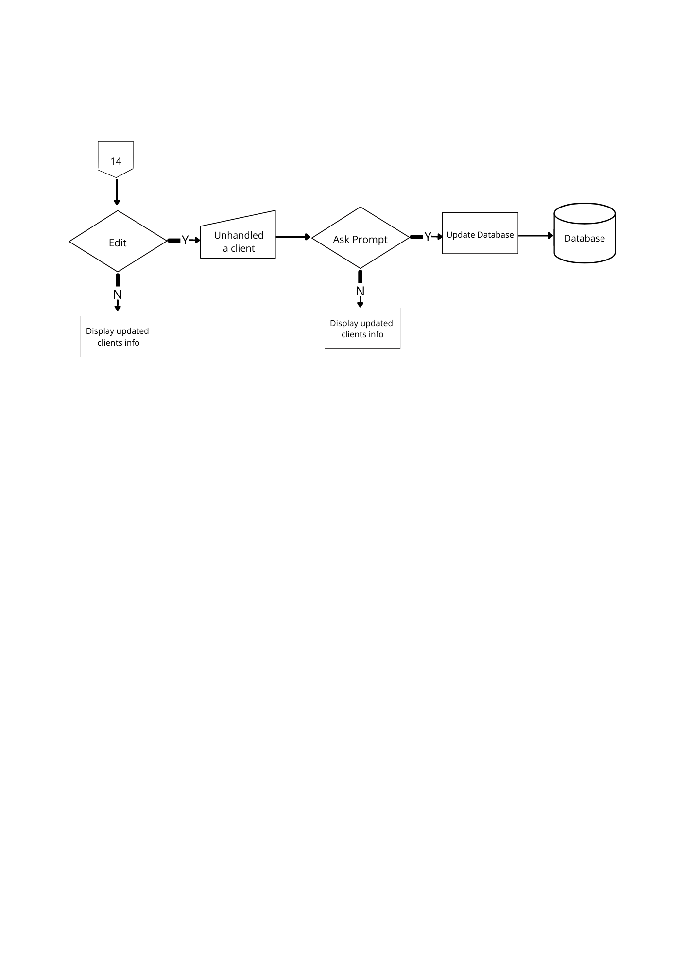

**Employee Portfolio Page**

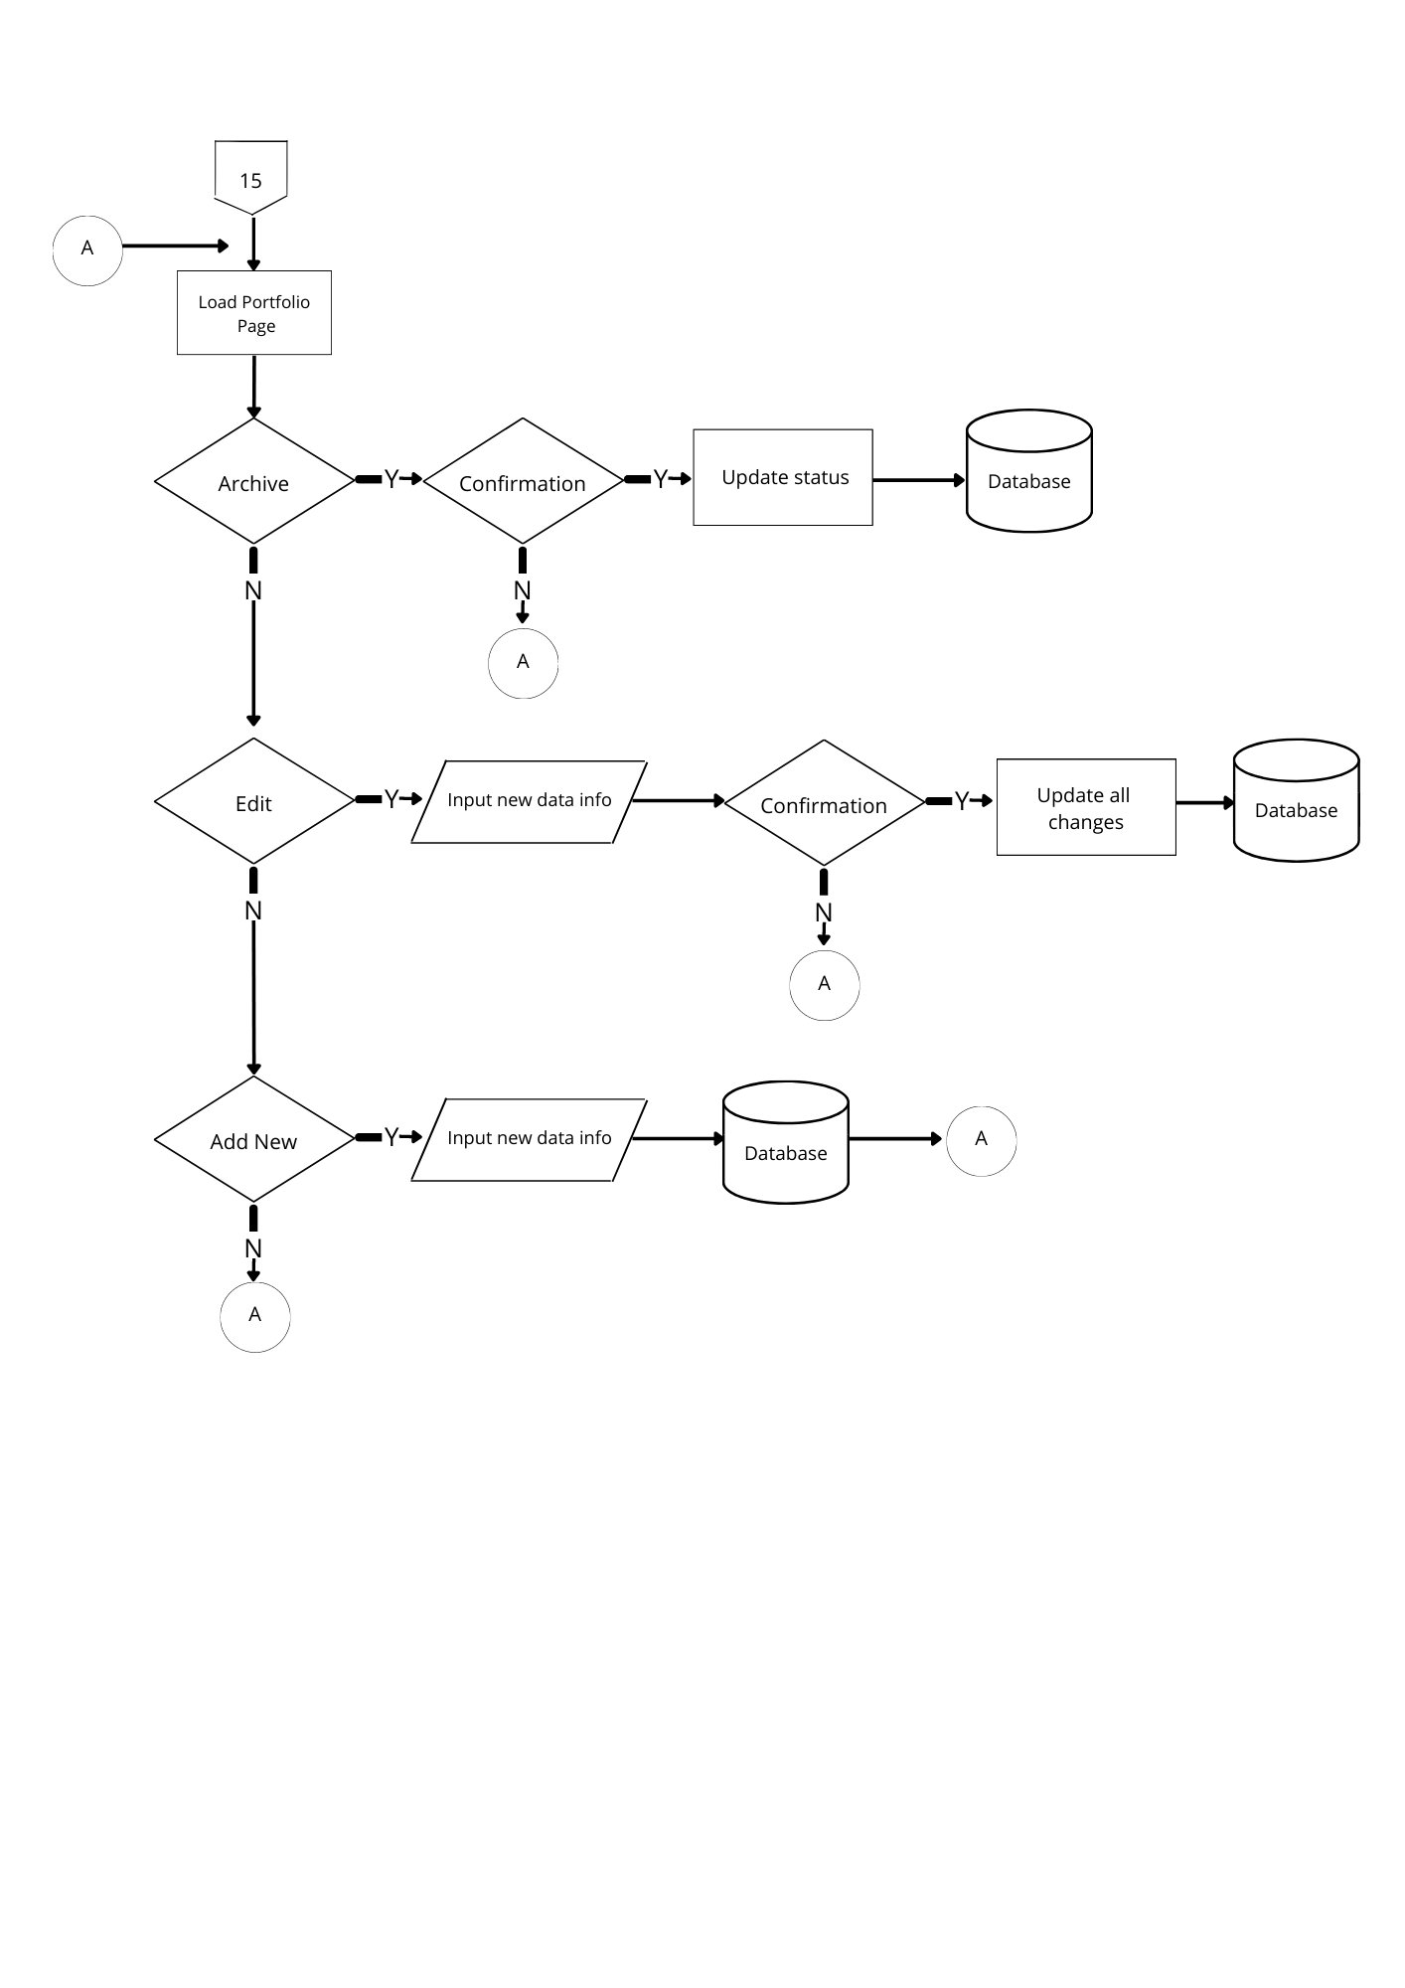

**Figure 18. Employee Portfolio Page Flowchart**

This figure indicates a portfolio of work samples that demonstrate your ability to potential employers.

**Entity Relation Diagram (ERD)**

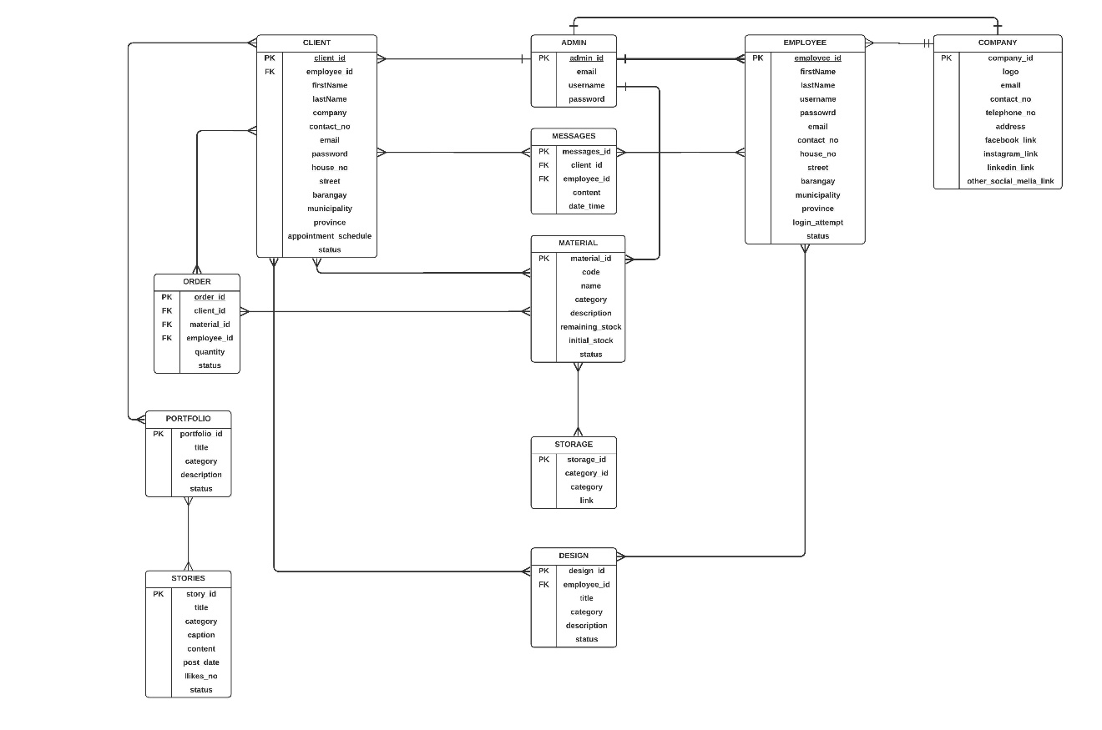

**Figure 19. Entity Relation Diagram**

This diagram illustrates an entity relationship diagram (ERD). It demonstrates and illustrates how entities such as Admin, Company, Employee, and Client interact with one another. Entity relationship diagrams, as shown in this image, give a visual starting point for database design and may be used to help determine information system requirements throughout an organization.

**Visual Table of Content**

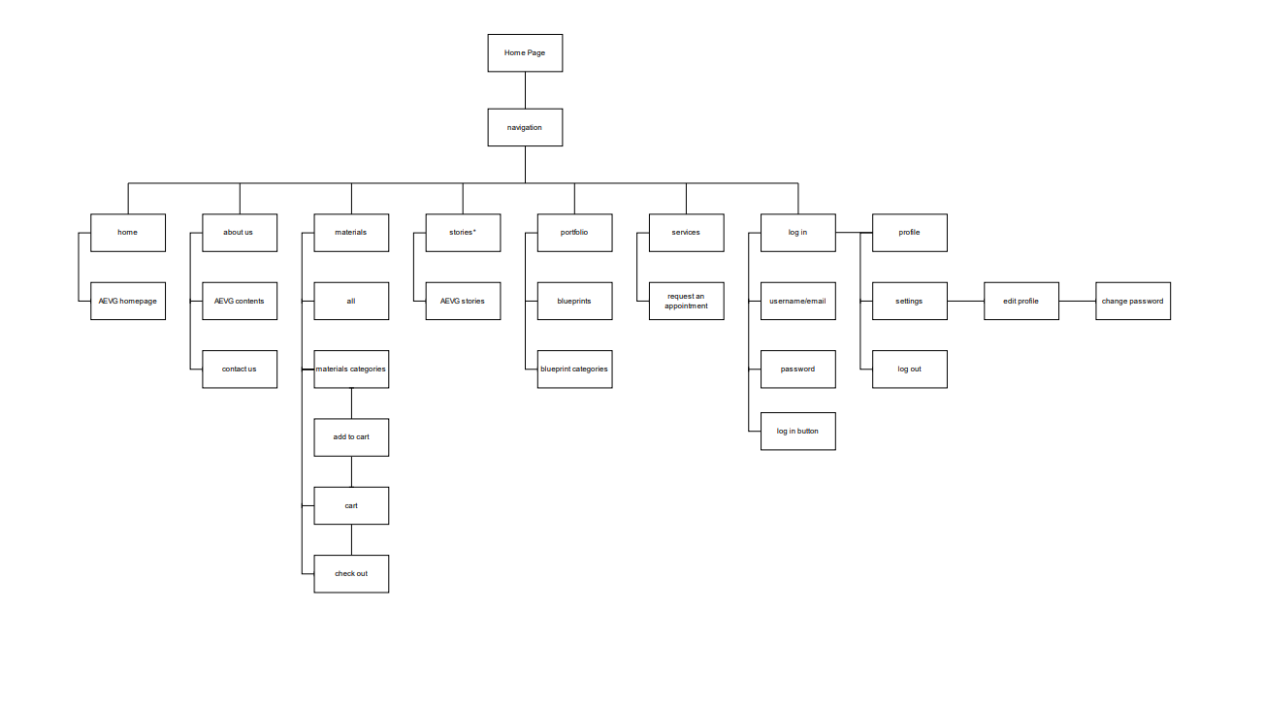

**Figure 20. Visual Content Diagram**

The figure above shows the different function of the website of our system. Clients will be able to browse portfolios, check materials, check stories, request an appointment and read all about us. Clients can also do other task such as edit profile and change password.

**Description of the Prototype**

This section presents the initial design or prototype of the system and its included features. The initial design focuses on the layout of the UI and ensuring all functions have been included and accessible in the system.

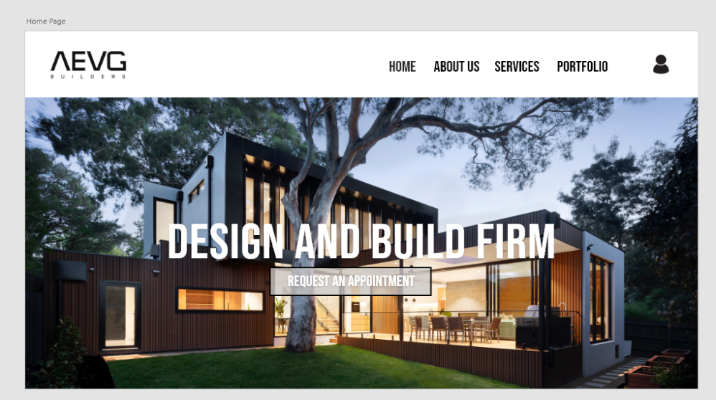

**Figure 1.Home Page**

This figure shows the Home Page of our system. It contains Home, About us, Services and portfolio sections.

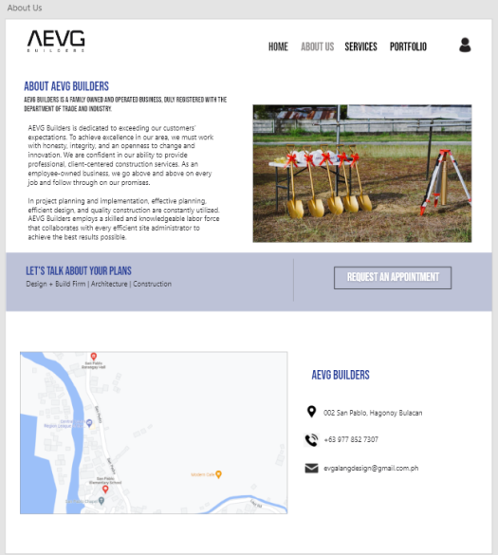

**Figure 2. About Us**

This figure shows the about us page of our system where the company information is stated and the location is illustrated.

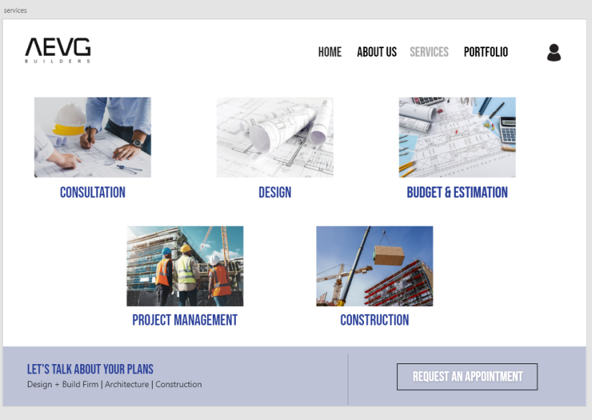

**Figure 3. Services**

This figure shows our services page that offers to talk about the plans in terms of designs, architecture, and construction that would choose by the client.

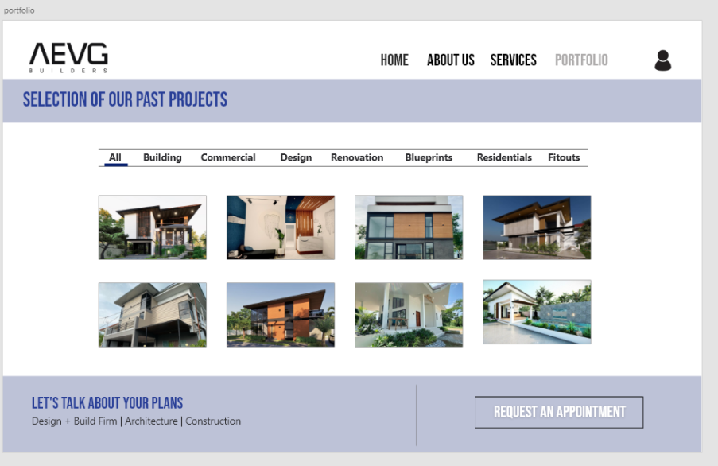

**Figure 4. Porfolio**

This figure shows the Portfolio page of our Website where the client could see the selection of our past projects.

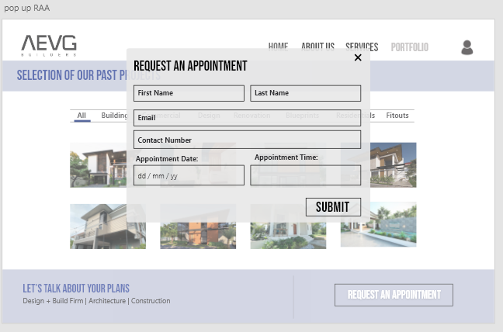

**Figure 5. Pop Up Request An Appointment**

This figure shows the request an appointment page whether if the client wants to have a scheduled meeting with the architect.

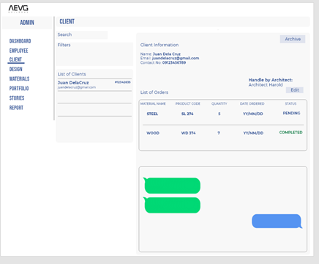

**Figure 6** **Admin Side - Client View**

This figure shows the client section of our system. You can search client names and view their information’s as well as the conversation that you made.

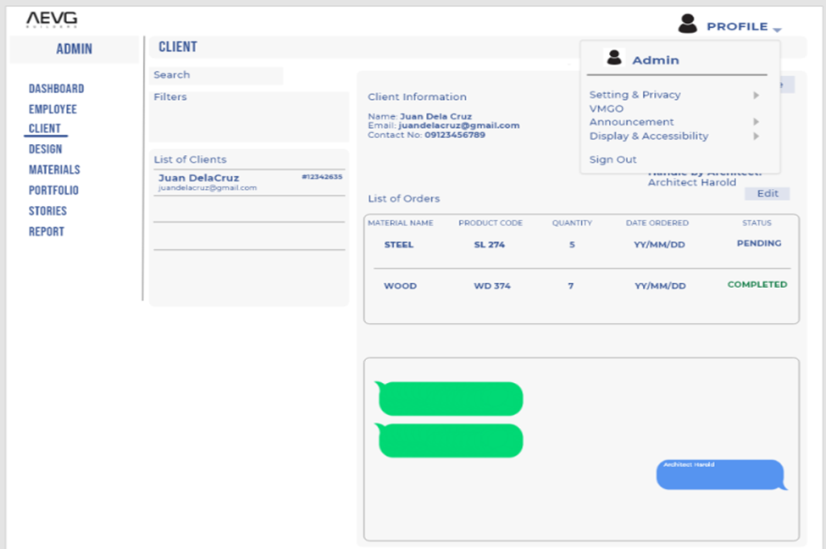

**Figure 7. Admin side- Client view dropdown**

This figure shows the client section of the admin side of our system where the admin can check the personal information of the clients and the list of material that has been ordered. This also capable of messaging the client.

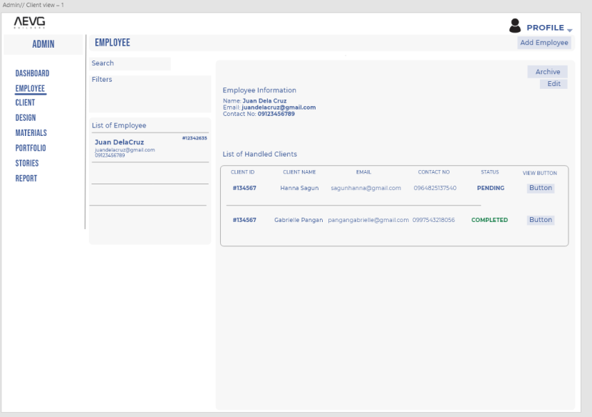

**Figure 8. Admin Side- Employee’s view**

This figure shows the view of employee section in admin of our system. The admin is able to view the employee info and the clients that they hold.

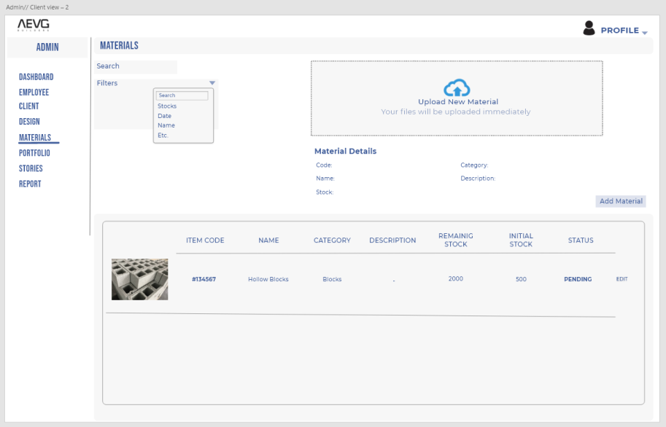

**Figure 9. Admin side- Material’s View**

This figure shows the material section of our system. Able to search material name and it is also capable of uploading and updating material information’s.



**Figure 10. Material Page**

This figure shows the  admin material page of our website that offers different kinds of architectural products that can be bought by the client.

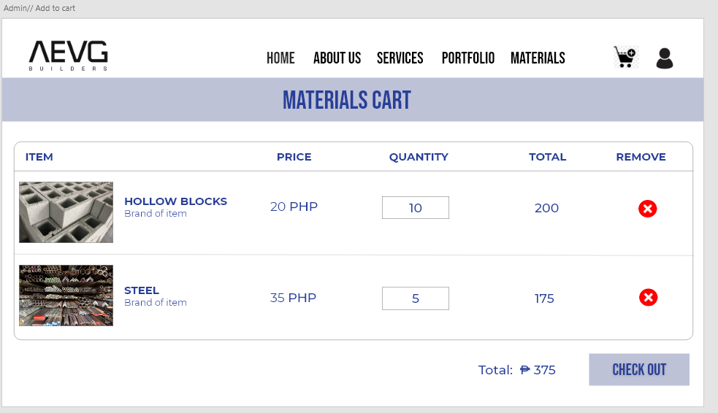

**Figure 11. Client Side- Orders View**

This figure shows the materials cart page of our website where the client could add, remove or place an order.

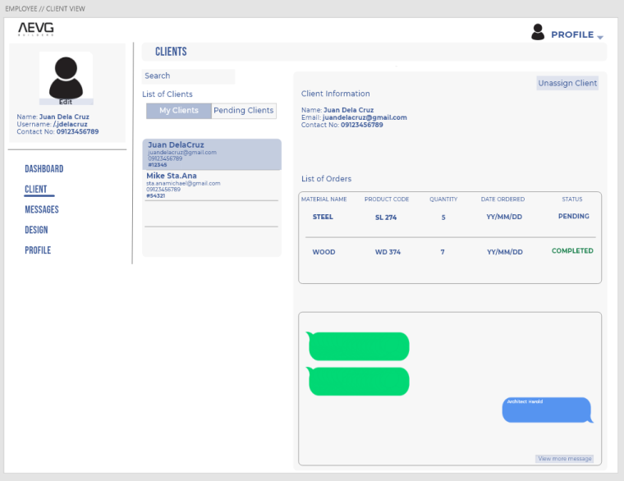

**Figure 12. Employee Side- Clients View**

This figure shows the view of client section of the admin view of our system where can u check and chat to the client.

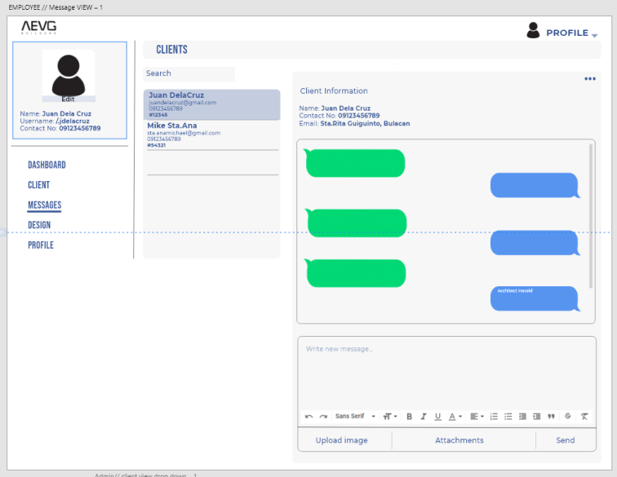

**Figure 13.Employee Side- Messages View**

This figure shows the message section of the employee.

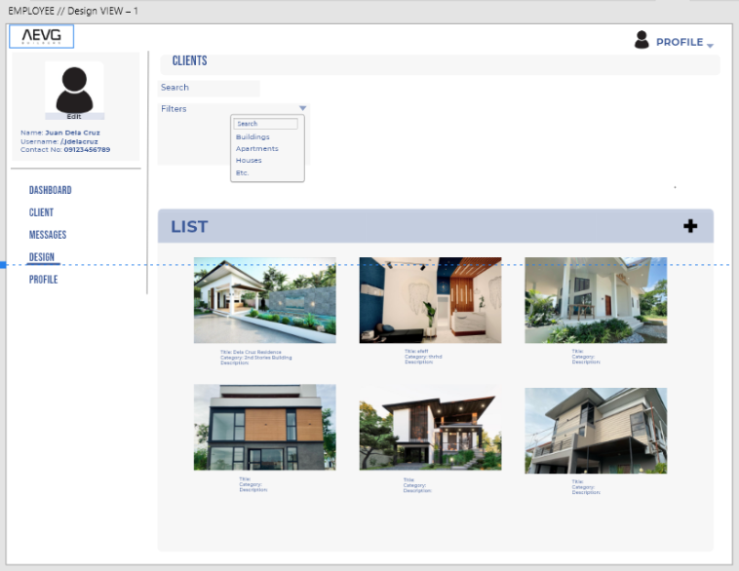

**Figure 14. Employee Side- Design View**

This figure shows the design section of the employee view of our system where you can check and view designs.

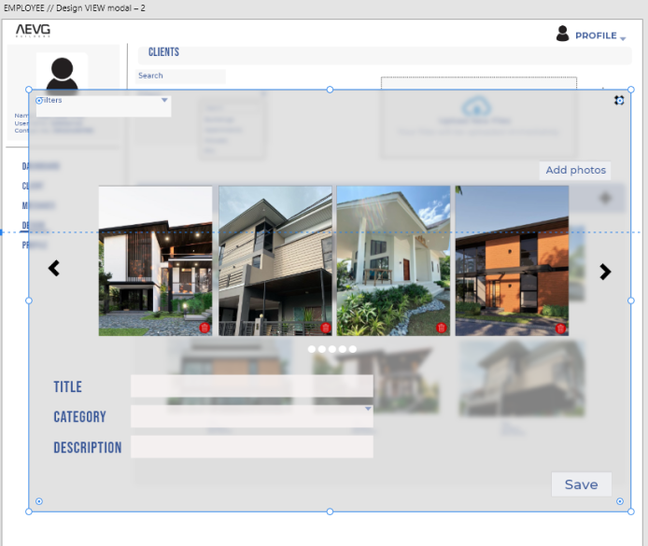

**Figure 15.Employee Side- Design View Modal**

This figure shows the design section of the employee view of our system where you can check and view designs.

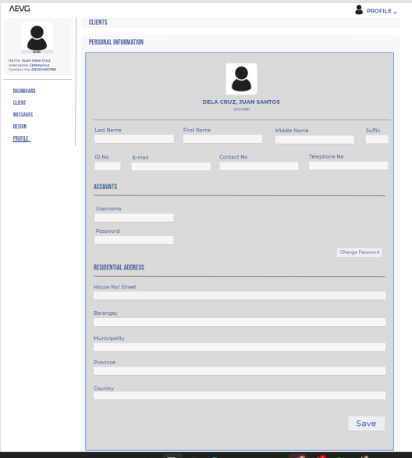

**Figure 16.Employee Side- Profile View**

This figure shows the profile of the employee where can be edited by the user.

**BIBLIOGRAPHY**

**A. Review of Relevant Theories**

Aerts, A. T. M., Goossenaerts, J. B. M., Hammer, D. K., & Wortmann, J. C. (2004). Architectures in context: on the evolution of business, application software, and ICT platform architectures. Information & Management, 41(6), 781–794.

[https://doi.org/10.1016/j.im.2003.06.002](https://l.facebook.com/l.php?u=https%3A%2F%2Fdoi.org%2F10.1016%2Fj.im.2003.06.002%3Ffbclid%3DIwAR1yWPFW1Mfv40i5AsDjNsC1cWIqoEx7zJtuYcZ_rf8UCR6rfxlZhfcOrBE&h=AT12ZjEGs4y-JjyzGsyx3rpAwM3-_-6KmSkH5OCMoq4n0DNFZCHk9GO-4xCezsQOeyoDZQ3gEGFcvuEQ_p-g2xVhhC7NcHE5PHBzshU7ijdeDBFRnBLrU3PLYUTl0aP-Ykh3Ww)

Changchit, C., Garofolo, T., & Gonzalez, J. J. (2009). A Cultural Study of E-Commerce Trust: Hispanic Versus Anglo. Journal of Information Science & Technology. Moum, A. (2006). A FRAMEWORK FOR EXPLORING THE ICT IMPACT ON THE ARCHITECTURAL DESIGN PROCESS. 11.

[https://www.itcon.org/papers/2006_30.content.07890.pdf](https://www.itcon.org/papers/2006_30.content.07890.pdf?fbclid=IwAR2nBPxUc_dHzykzoyfAr6XI1ko1N0K_GCvrvyrwglcX_MenrM0A6PVAWfQ)

Moum, A. (2008). ICT and the Architectural Design Process – Introduction of an ICT Impact Matrix. Retrieved May 16, 2022, from

[https://www.irbnet.de/daten/iconda/CIB6772.pdf](https://l.facebook.com/l.php?u=https%3A%2F%2Fwww.irbnet.de%2Fdaten%2Ficonda%2FCIB6772.pdf%3Ffbclid%3DIwAR0kqMCO_0igkLf3u9D7MVrH7XHavYbnrBGUH-K6KHelmhKx5CUV4uoEUPk&h=AT12ZjEGs4y-JjyzGsyx3rpAwM3-_-6KmSkH5OCMoq4n0DNFZCHk9GO-4xCezsQOeyoDZQ3gEGFcvuEQ_p-g2xVhhC7NcHE5PHBzshU7ijdeDBFRnBLrU3PLYUTl0aP-Ykh3Ww)

**B. Review of Related Literature**

Georgiadou, Maria C. *“Building Information Modelling in UK Construction Projects: A   
 State of the Art Reviews”,* https://westminsterresearch.ac.uk/item/  
 9x159/building-information-modelling-in-uk- construction-projects  
 -a-state-of-the-art-review, 2016.

Karan, Ebrahim. , Asadi, Somayeh. “*Intelligent Designer: A Computational Approach to   
 Automating Design of Windows in Buildings”,* http://www.sciencedirect.com   
 /science/article/abs/pii/S0926580518305259, 2019.   
  
  
Negendahl, Kristoffer. *“Building Performance Simulation in the Early Design Stage: An   
 Introduction to Integrated Dynamic Models”,* <https://www.sciencedirect.com>  
 science/article/abs/pii/S0926580515000369#!,2015.

Joseph Chuen-huei Huang, “A Choice Model of Mass Customized Modular Housing by Internet Aided Design”, http://papers.cumincad.org/cgi-bin/works/paper/b428

Trisyanti, S W; Suwardhi, D; Murtiyoso, A; Grussenmeyer, P. , “Low Cost Web-Application For Management Of 3d Digital Building And Complex Based On Bim And Gis”, https://www.proquest.com/openview/7a0c267ab9a7d7b99683f351e54de67a/1?pq-origsite=gscholar&cbl=2037674, 2019.

Nanayakkara, MU; Anuradha, IGN; Liyanage, DLCP; Devapriya, KAK, “Developing a Cost-Effective Web-Based Communication and Information Management System for Construction Projects”, 2021

**Appendix D**

*Curriculum Vitae*

